Colour Wheel

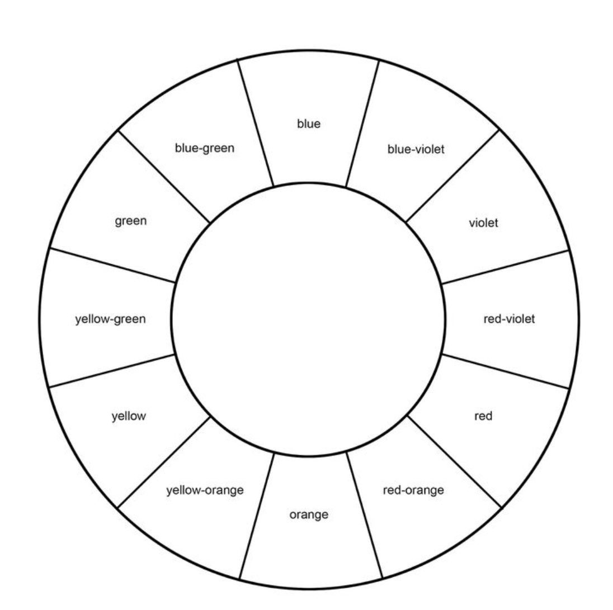
red-purple
purple
blue-purple

