WB 1/6/20 – Year 1 and Year 2 English
This week will be based on a video called ‘The Black Hat’.
https://www.youtube.com/watch?v=DoKavOfPkwo
Please watch the video as many times as you need to so that you are able to complete the tasks below.
There will be extra support sheets uploaded onto class pages.
Please complete 1 task a day, they can be done in any order.
Write character descriptions for both the mum and the boy. | Write a prediction of where you think the black hat has come from?  Why do you think this? | Write a diary entry from the boy to show the different events in the video. | Write a setting description of the forest at the beginning of the video and at the end.  (Look at the pictures below) | Make/draw your own bird, be creative.  Then write about your bird.  What does it look like? What noise does it make? What does it eat?  Where does it live? How old is it?  Any other information you want to add is great!

Beginning
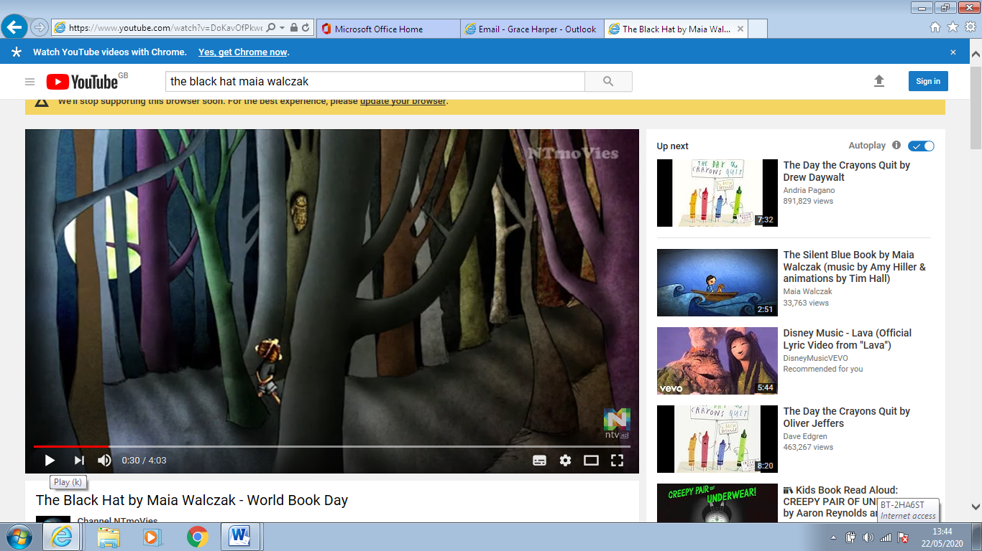
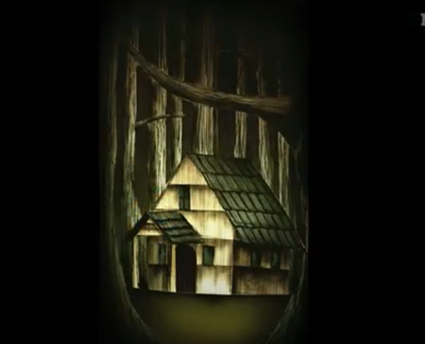

End


