Project 1: Puppet Theatre

Learning Objective: I can create my own puppet theatre with roleplay
Inspire young minds to get creative with this fun kids’ activity! Younger ones will need help using scissors to cut the cardboard and fabric, but kids of all ages can enjoy playing and creating stories with this colourful DIY toy.
Prep 3-5 hours + drying time
You will need
- Cereal box
- Acrylic or poster paint
- Fabric
- Ribbon
- Coloured card
- Decorations (such as pom-pom trim, buttons or sequins)
- A4 white card
- Long sticks, such as wooden skewers, straws or thin dowel rods
Equipment
- Scissors
- Sticky tape
- Ruler
- PVA glue
Children could roleplay their stories to the class.

Step one
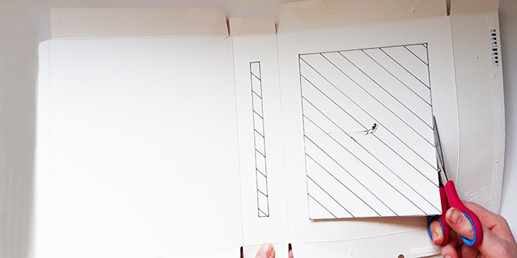
Open out your cereal box, being careful not to rip it. Cut out one slot into the side of the box, about 1cm wide. Then cut a large rectangle out of the front of the box, leaving about 2.5cm of card around the edge. Paint in your chosen colour and allow to dry.
Step two
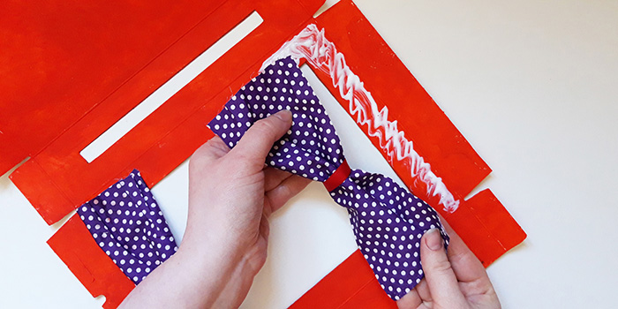
Cut out two panels of fabric about 6cm wide x the width of your box. Wrap ribbon around the centre, tying a knot at the back. Glue curtains to either side of the large opening and allow to dry.

Step three
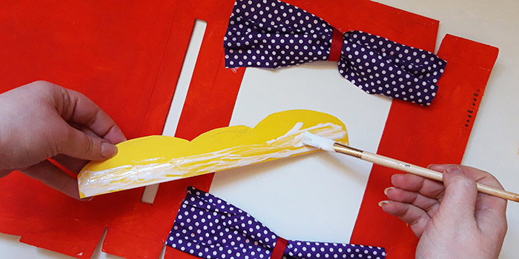
Cut out a piece of coloured card the height of your box (or multiple pieces, if your box is large) and about 4cm wide and cut wavy shapes along the bottom edge, as shown in picture. Glue in place over the top of the ‘curtains’ and allow to dry.
Step four
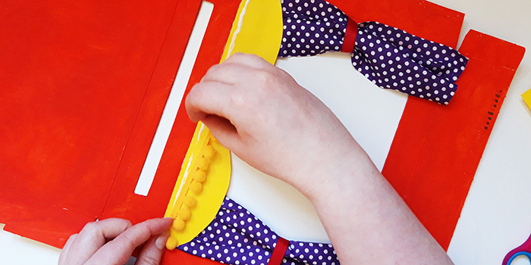
Glue on any decorations, such as a pom-pom trim, some buttons or sequins. Then reassemble the box, sticking the edges with glue and leaving one end open. Allow to dry.

Step five
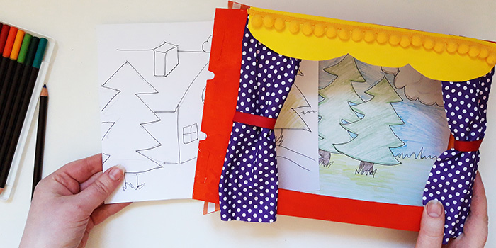
Make some backgrounds for your story by cutting out some white card slightly smaller than the back of your cardboard box. Decorate with scenes from your story, then insert into the open side of your theatre – these can easily be swapped when you want the background to change!
Step six
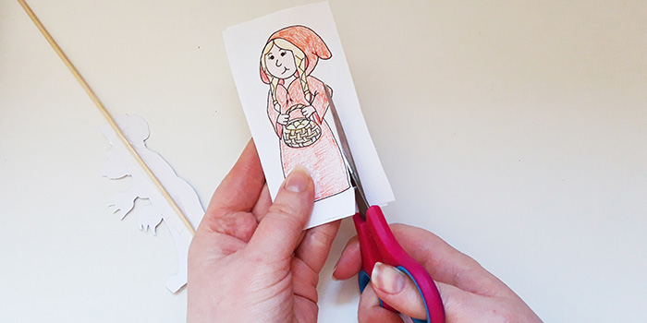
Print out the characters and colour them in, or create your own. Glue your finished characters to some card, cut out and then attach a long stick to the back using sticky tape.

Characters for Puppet Theatre – Reception & Year 1


