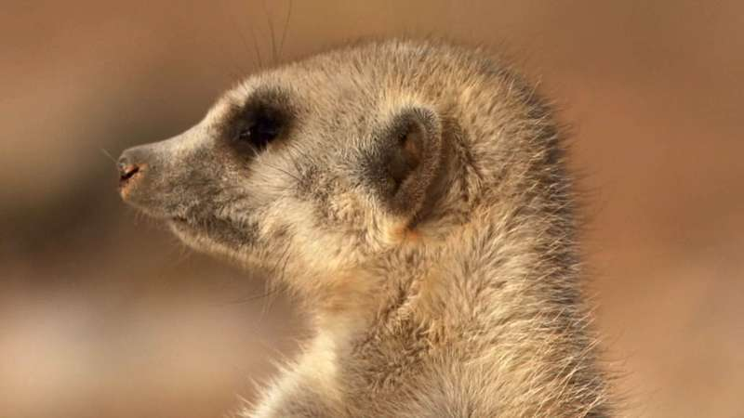
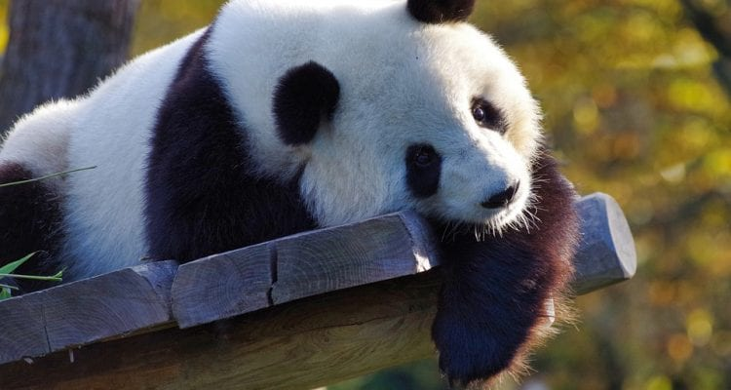
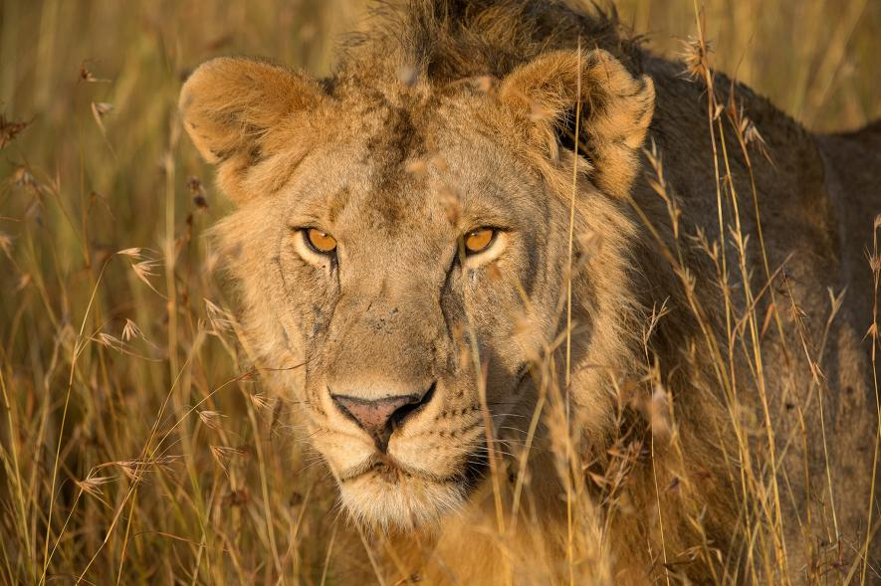
Mr Deakin’s
n
i
ma
Puzzle Book

Carnivore, Omnivore, or Herbivore

Sort the animals into the correct section of the venn diagram

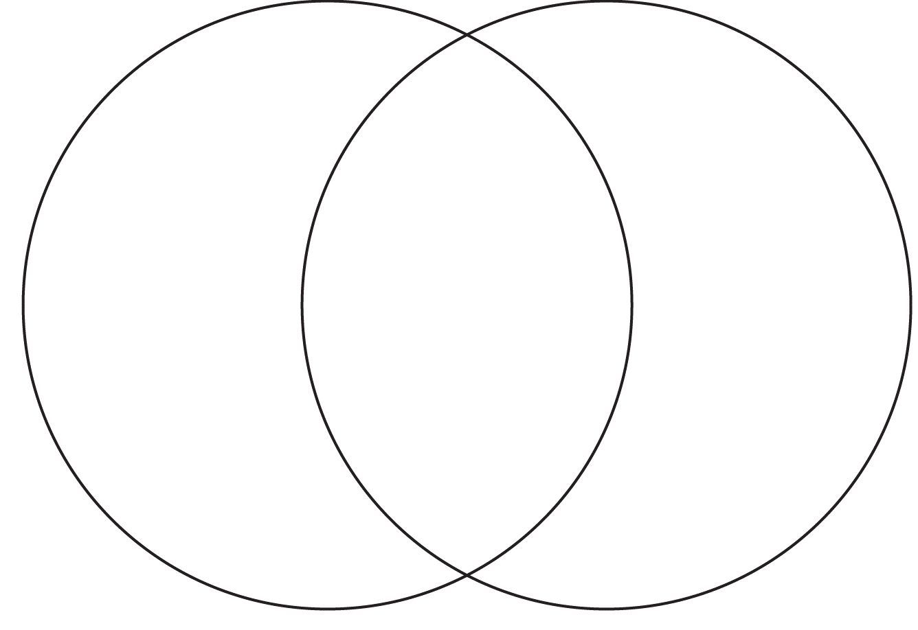
Carnivore
Omnivore
Herbivore
Squirrel
Cow
Monkey
Tiger
Horse
Eagle
Rabbit
Lion
Deer
Polar Bear
Badger
Giraffe
Pig
Frog
Dolphin
Rhino

Draw the correct line from the animal structure to the classification

Gills
Hair/Fur
Scales/Dry Skin
Feathers
Land/Water
Birds
Reptiles
Amphibians
Mammals
Fish

Can you work out the animal?
I can live in the wild or a zoo.
I am a herbivore.
I am a mammal.
I have tusks.
I am grey.
What am I?

I live in the ocean
I am a carnivore
I have blowholes.
Free Willy is one.
What am I?

I live in ponds.
I am a carnivore.
I jump.
I am an amphibian.
I lay eggs.
What am I?

I live on a farm.
I am a herbivore.
Wool comes from me.
I am a mammal.
My young are called lambs.
What am I?

Can you write what am I clues for ……
Miss Harpers favourite animal!
I can be a pet.
I am a mammal.
I am an omnivore.
I have four legs.
I bark.
What am I?

