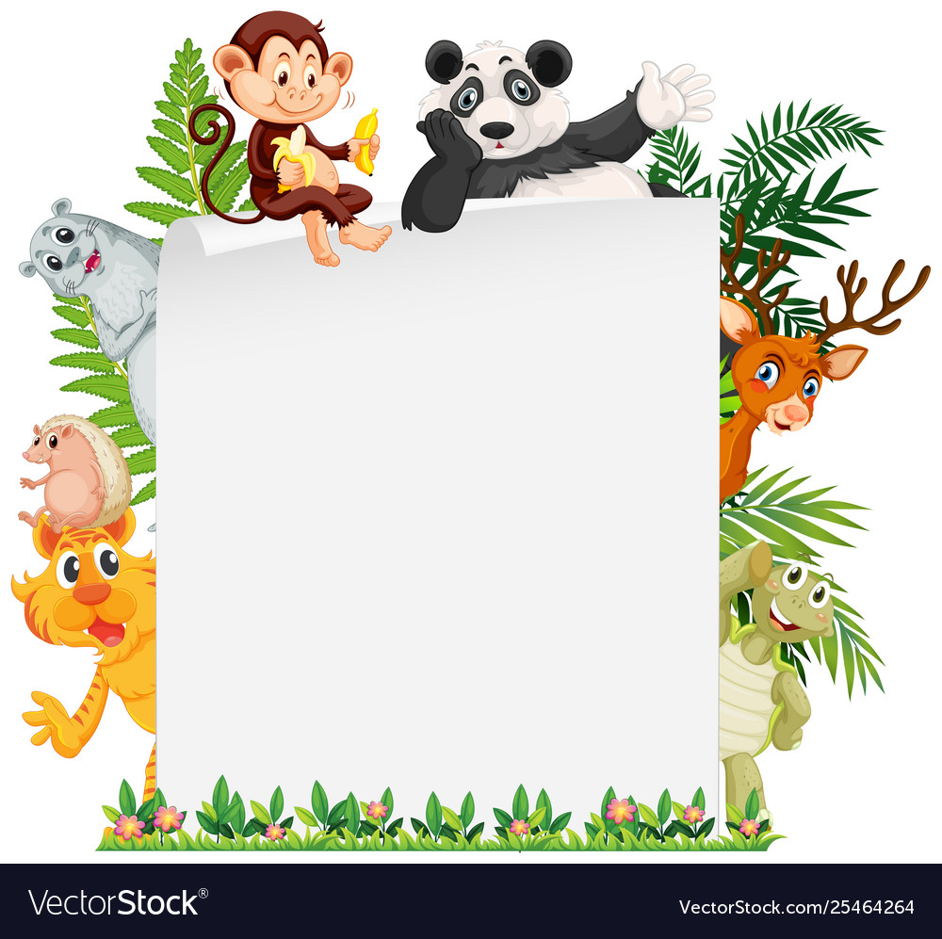
Watch this video (https://www.youtube.com/watch?v=4VixROiu8Qg&feature=youtu.be) a few times so you get use to the song and lyrics.

Then draw your favourite animal from each classification (fish, birds, etc.) and record yourself singing the song with your drawings appearing at relevant times.

I look forward to seeing your best dance moves, singing voices and drawings!

Mr Deakin

