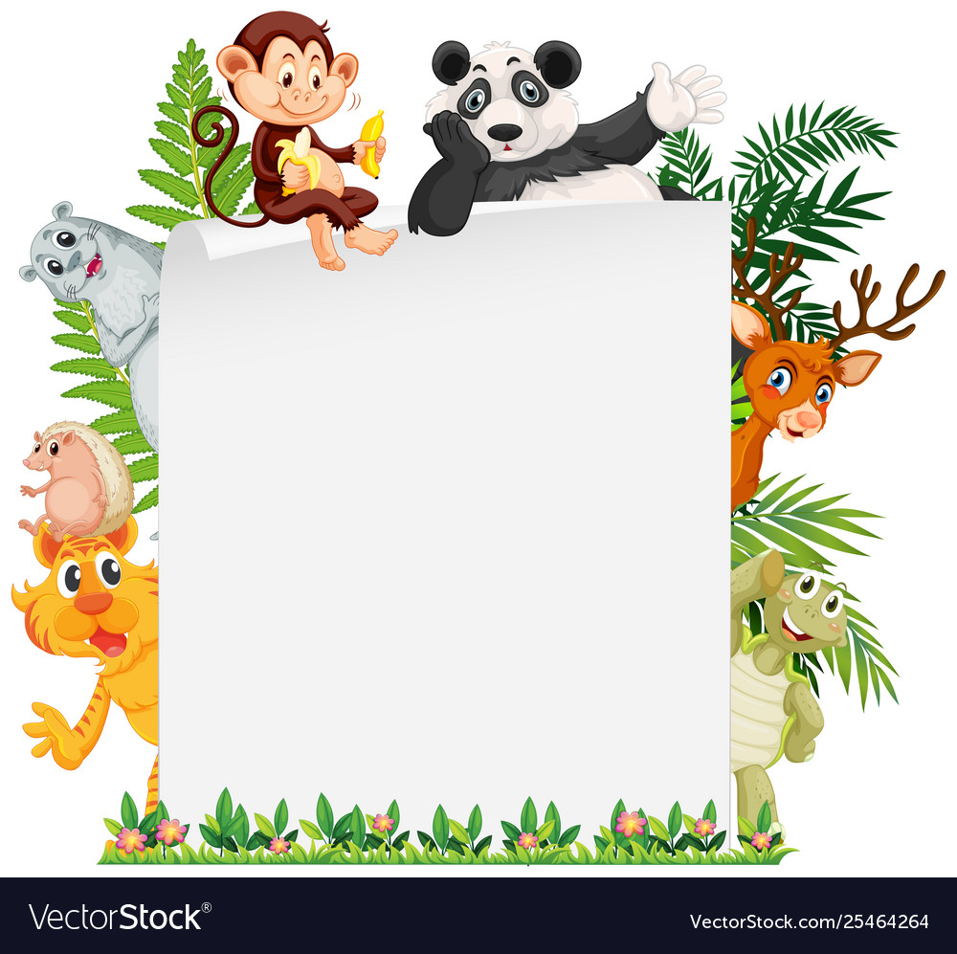
Watch the classification song (https://www.youtube.com/watch?v=4VixROiu8Qg&feature=youtu.be) again so you’re familiar with the words and classifications.

Then attempt both sheets of questions in your book. The first one is to name the classification of the animals (Bird, Reptile, Amphibian, Mammal, Fish). The second is answering questions about each classification.

Enjoy!

Mr Deakin

