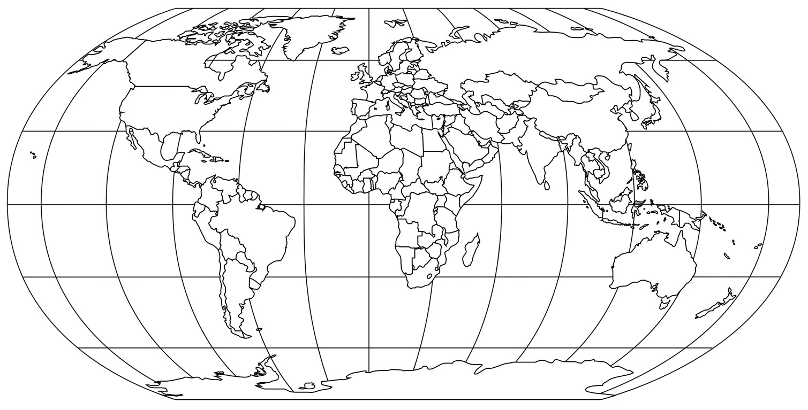
What is Wonderful about Our World?
Homework tasks:
We are exploring the seven continents and five oceans of the world. Your homework tasks are set around exploring the continent of North America. Please remember that you can pick as many of the tasks as you like, and can bring them in at any point before the Easter holidays.
- Create a picture or sculpture in the style of traditional North American Indian art.
- Create a map of North America – you could do a drawing, collage, painting or produce it on a computer.
- Write a postcard home from somewhere in North America.
- Create a fact file about animals living in North America, or perhaps make a mobile with images and facts!
- Read a book or poem by a North American author and create a review.
- Listen to some music from North America and create a review.
- What is Thanksgiving? Find out and make a fact file.
- What is the biggest island in North America? Find out and create a poster about this place.
- What is Death Valley? Find out and share what you know.
- North America is famous for going into space – what can you find out about this? Or even make your own space-ship!
- Re-create the flags of the countries in North America.
- What Oceans surround North America? What can you find out about these oceans?
- If you have visited a country in North America, create a collage of your holiday including pictures and the places you visited.
- Do you know someone who has been to North America? Interview them about what it is like there.
- What languages are spoken in North America? Can you learn to say hello in some of them?
**If you have any South American instruments at home, please bring them in for w/b March 9th. These could be maracas, pan-pipes, small drums or a small guitar.**

