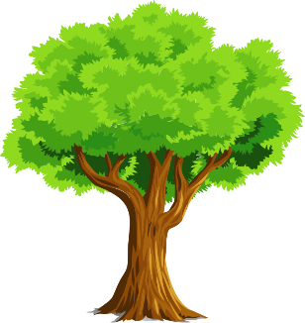
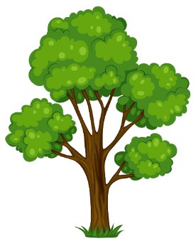

Science
LO: I can identify deciduous and evergreen trees
Watch the video (https://youtu.be/RJx2xQKIgXU) a few times so you clearly understand the difference between deciduous and evergreen trees. Then once you are confident move on to completing three of the following sheets:
- Evergreen wordsearch
- Deciduous wordsearch
- Evergreen worksheet
- Deciduous worksheet
- Sorting Worksheet
- Sorting Worksheet 2
- Understanding

What kind of tress can you find in your garden or near where you live?

