Project 7:
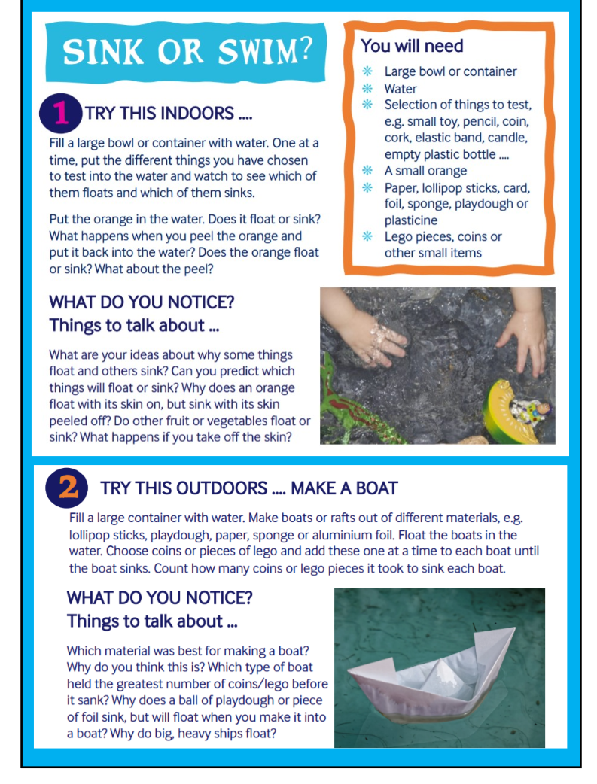

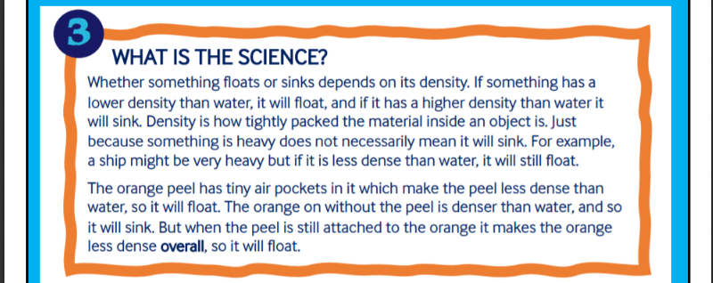
Links to support Learning about ‘Floating and Sinking’
Messy Goes to Okido
https://www.bbc.co.uk/cbeebies/watch/messy-goes-to-okido-why-do-things-sink-and-float
Maddie’s Sinking and Floating Song
https://www.bbc.co.uk/cbeebies/watch/do-you-know-sinking-and-floating-song
Why do things sink or float? More suitable for KS2
https://www.youtube.com/watch?v=2dyCe1GPagE
What is buoyancy?
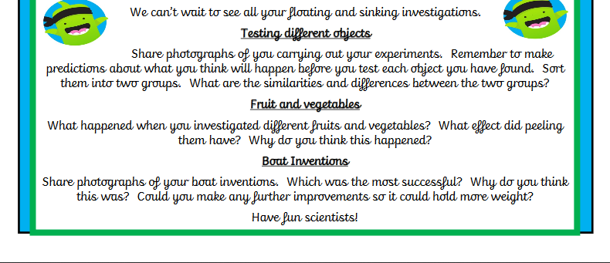
https://www.bbc.co.uk/bitesize/topics/zc89k7h/articles/zytqj6f

