Pioneers
- Create a superhero, some ideas below or you can create your own.
- Don’t forget it needs a special super power and a name.
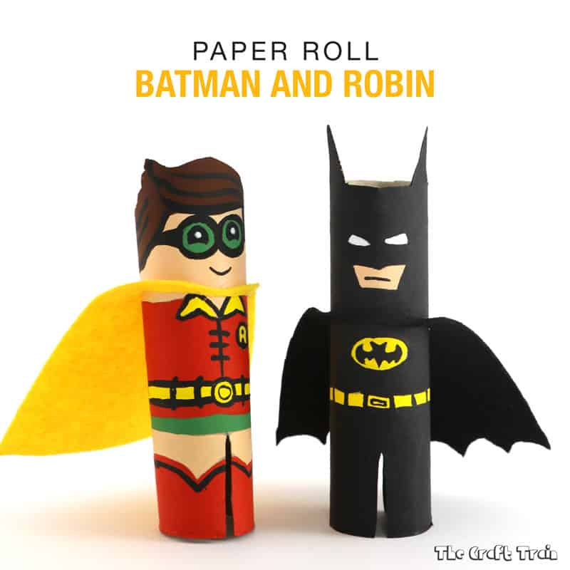  Loo roll heroes! | 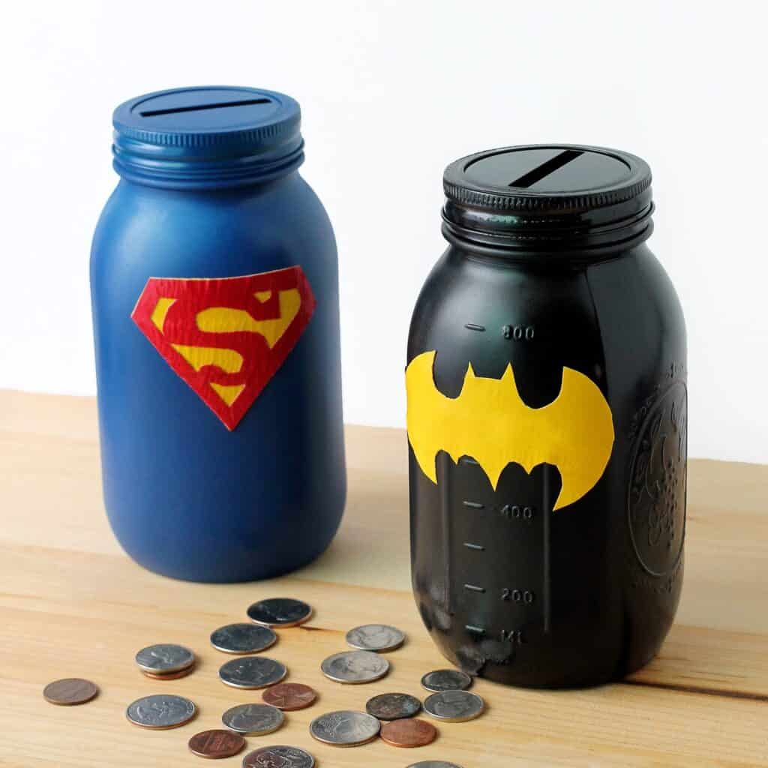  Super savings! | 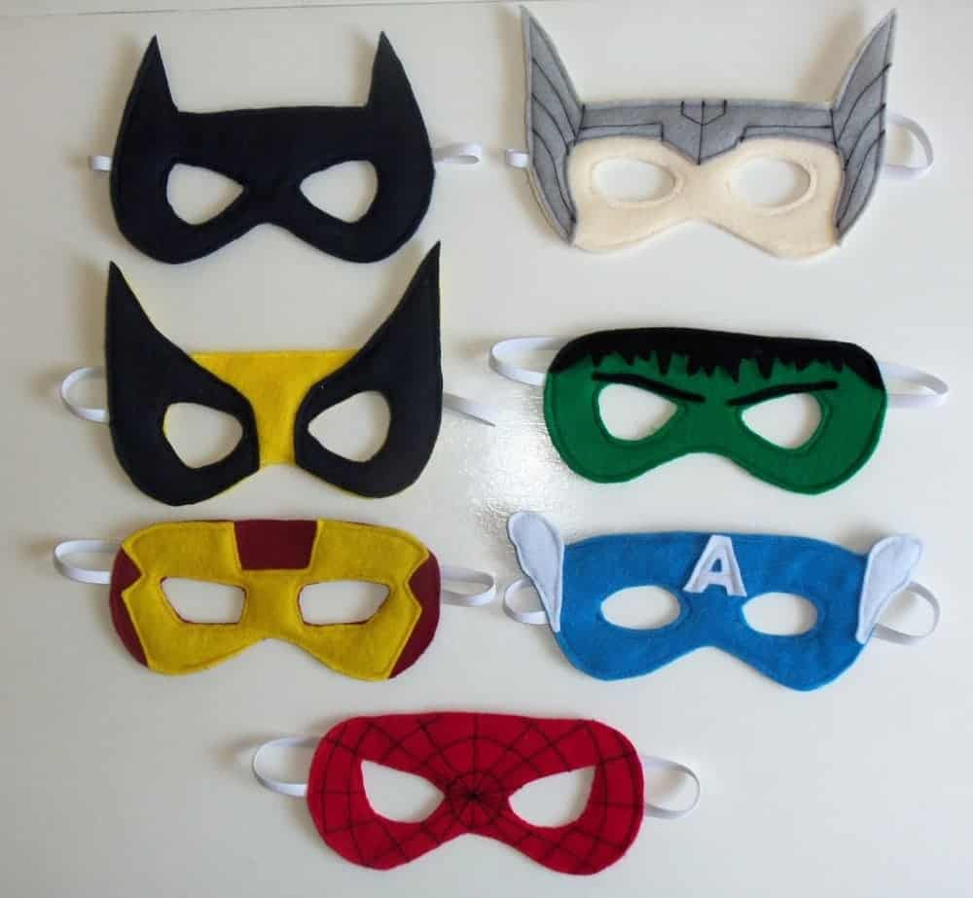  Who is behind the mask?
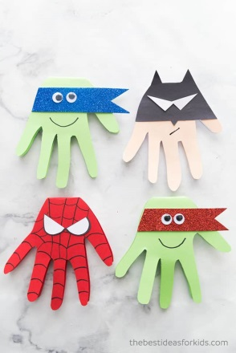  Heroic hand-prints! | 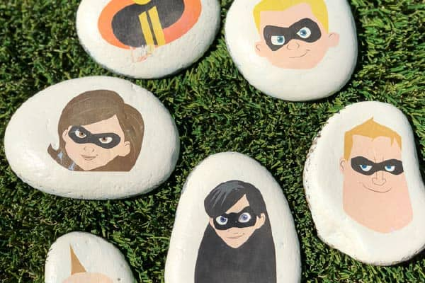  Super stones! | 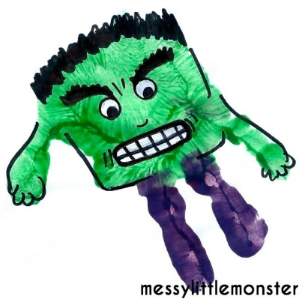  Hulk hand-prints!
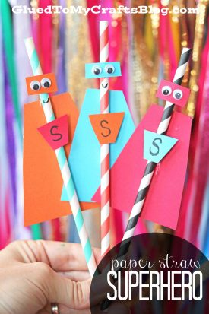  Super hero straws | 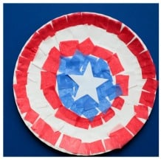  Shields! | 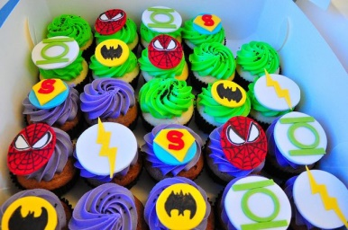  Cool cupcakes!

