Joe Wick’s Challenge

Can you complete a Joe Wick’s workout?

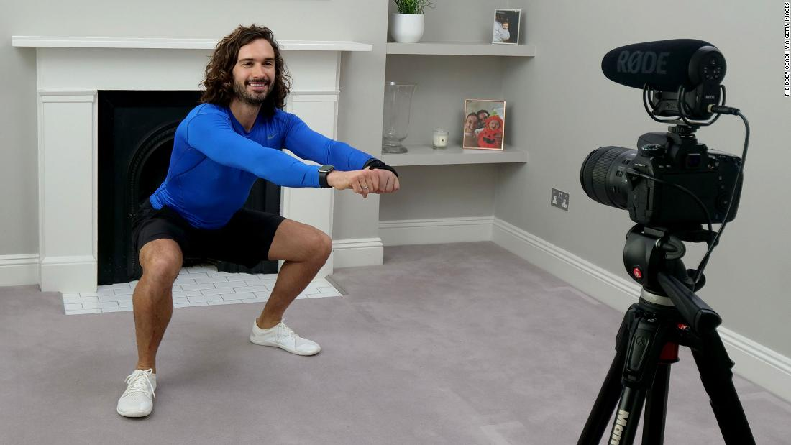

Share your video to be in with a chance of being named our ‘Joe Wick’s Champion’.

