Plank Challenge

How long can you plank for?

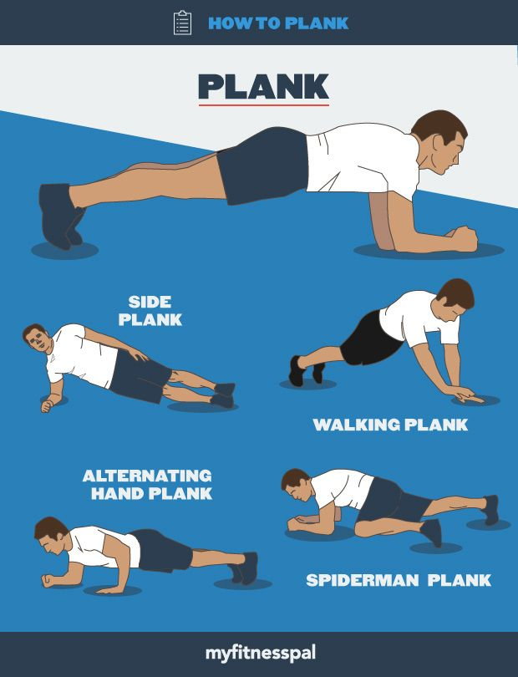

Share your video to be in with a chance of being named our ‘Planking Champion’.

