Keepy Uppy Challenge

How many ‘keep uppys’ can you do in 2 minutes?
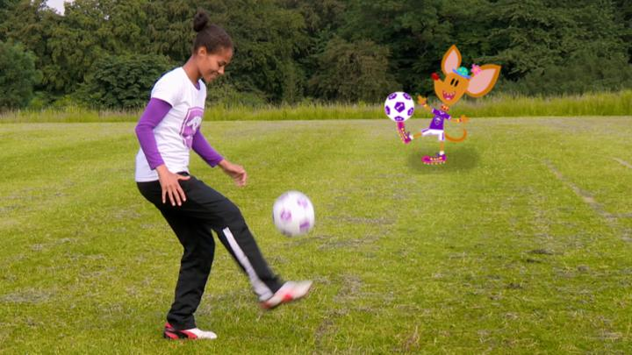


Share your video to be in with a chance of being named our ‘Keepy Uppy Champion’.

