Stand Up and Sit Down Challenge

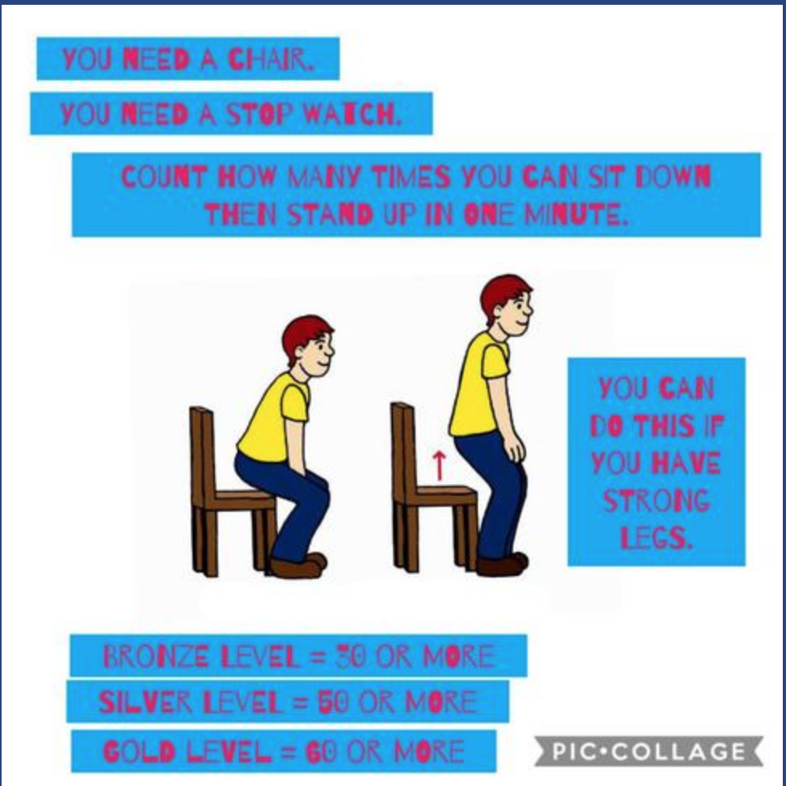

Remember to share your photographs and videos.

