Distance Jump Challenge

How far can you jump?

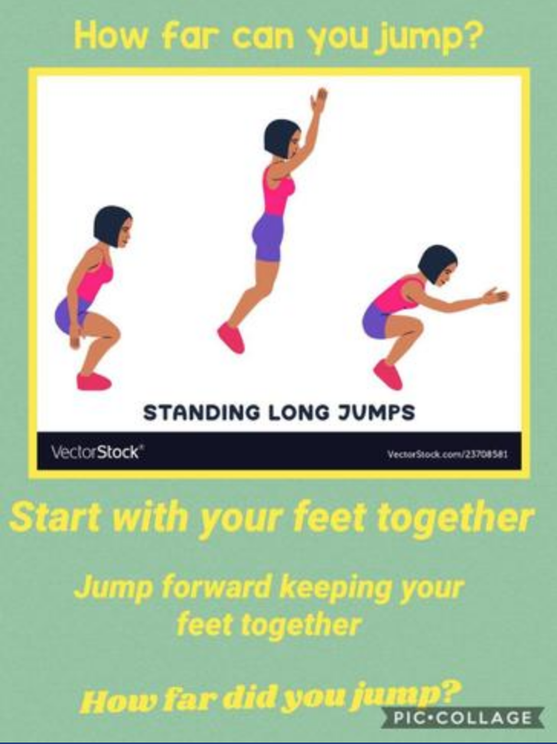

Remember to share your photos and results with us.

