Spell your Name Challenge
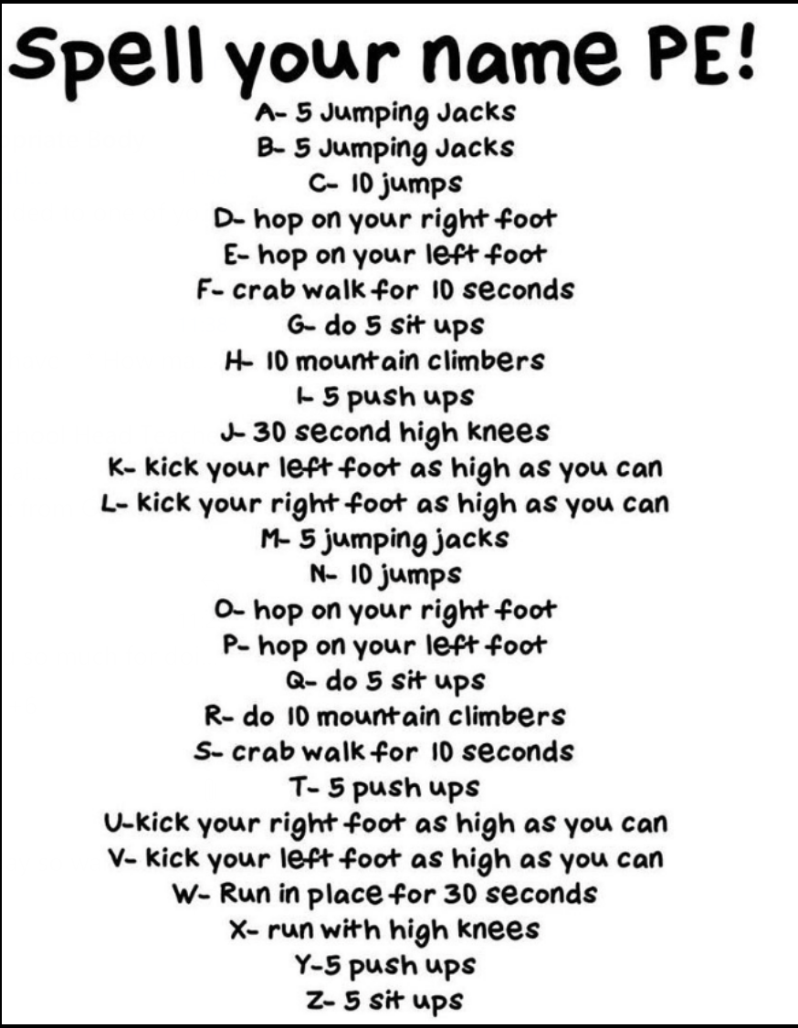

Spell your name and follow the instructions next to each letter.
Remember to send us your videos or photos.

