Egg and Spoon Challenge

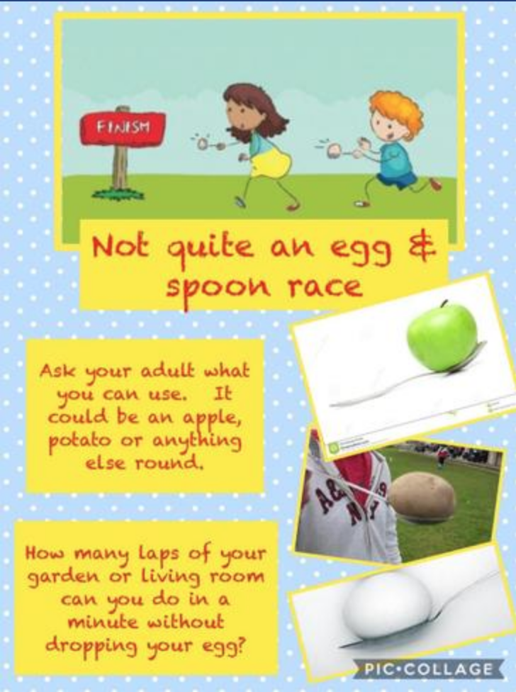

Share your video to be in with a chance of being named our ‘Egg and Spoon Champion’.

