Burpees Challenge

How many burpees can you do?

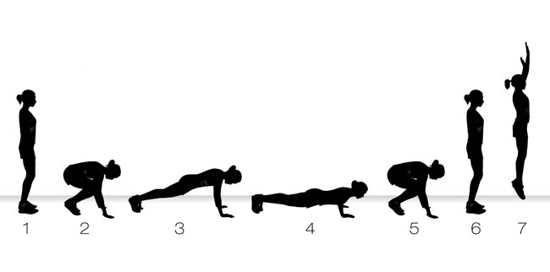

Share your video to be in with a chance of being named our ‘Burpees Champion’.

