Book Balance Challenge

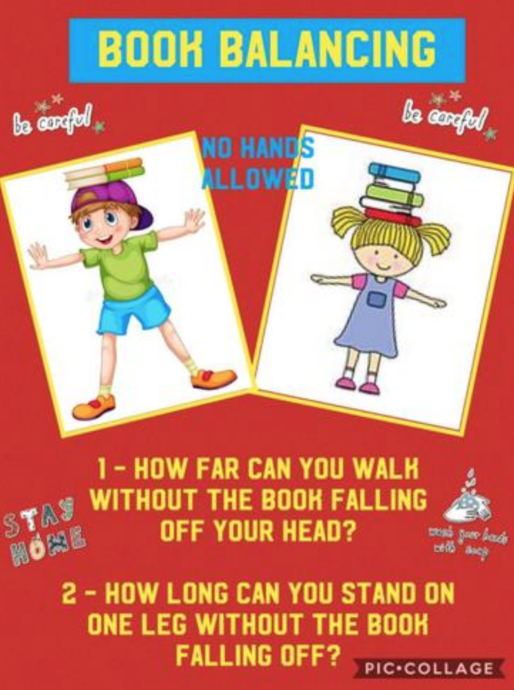

Share your video to be in with a chance of being named our ‘Book Balance Champion’.

