Throw and Claps Challenge

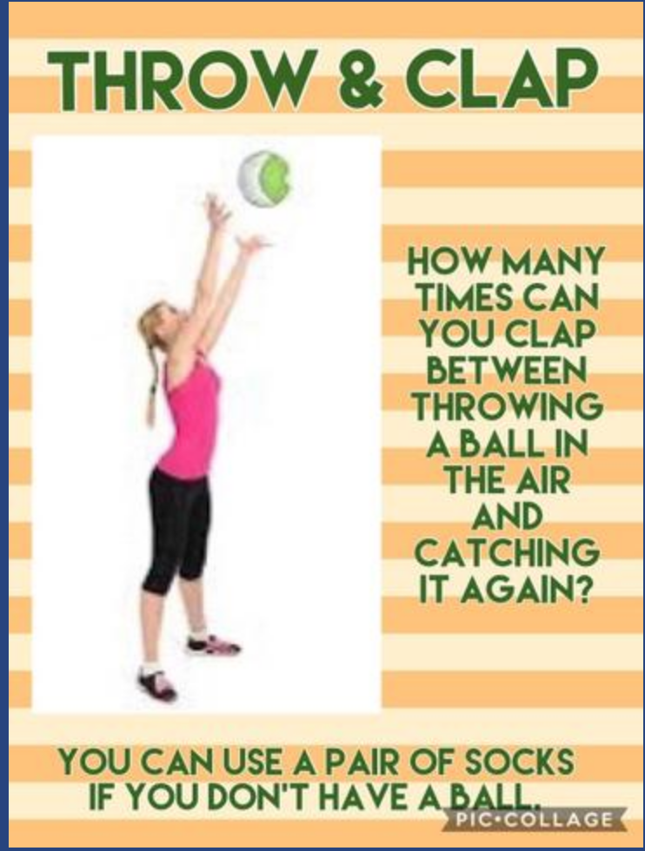

Remember to share your videos and photographs.

