Obstacle Challenge

Create an obstacle course at home with at least 5 stages. See how quickly you can complete it.

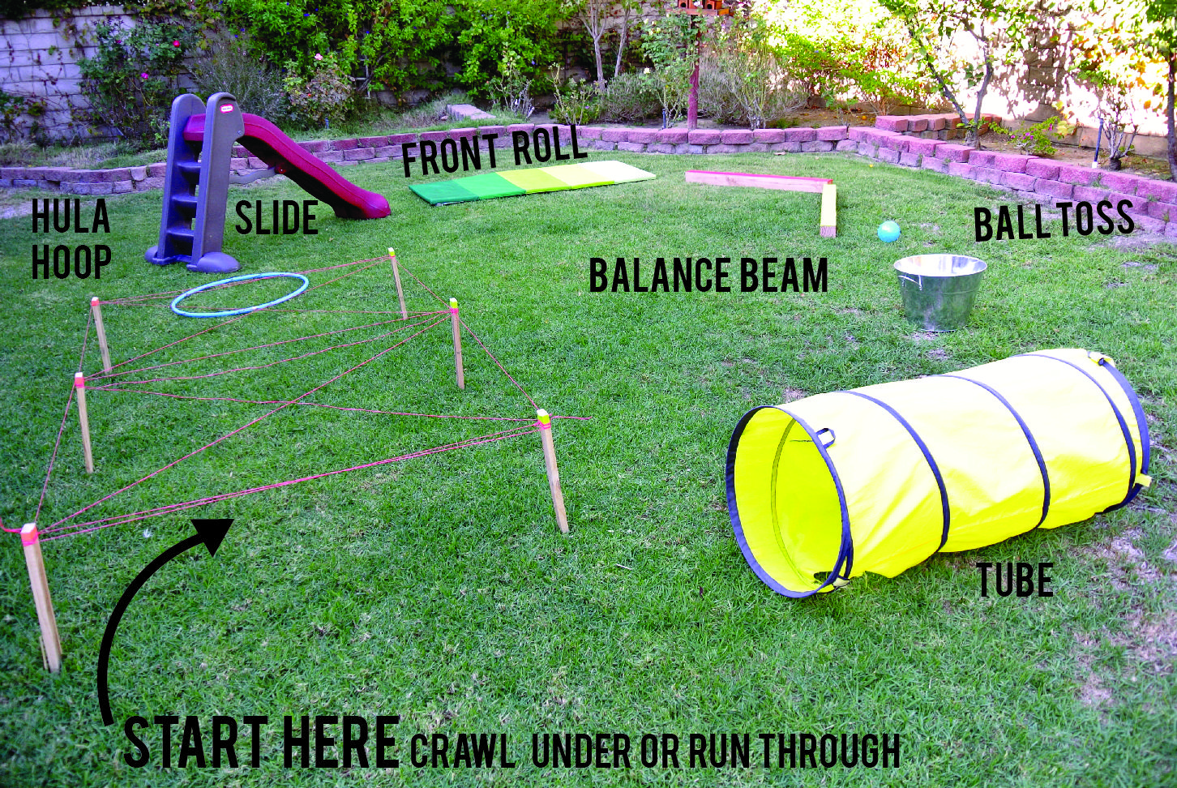

Share your video to be in with a chance of being named our ‘ObstacleChampion’.

