Washing Line Challenge

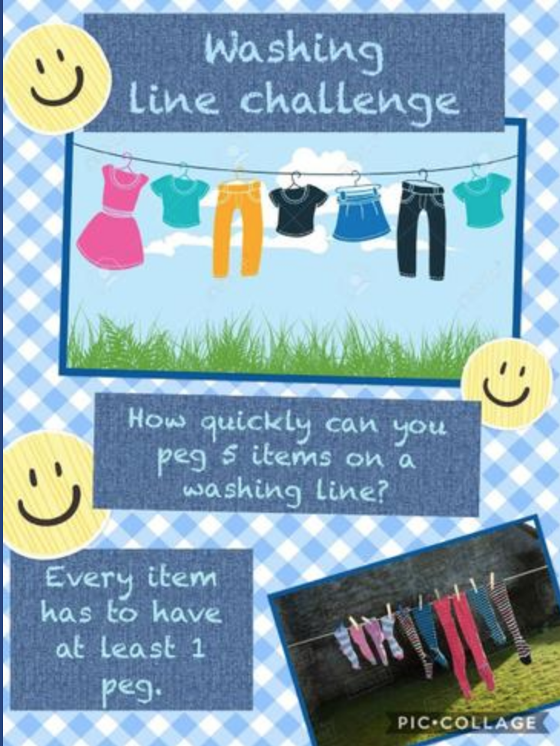
Share your video to be in with a chance of being named our ‘Washing Line Champion’.

