Gymnastics Challenge

Can you create a gymnastics routine involving at least 4 balances?

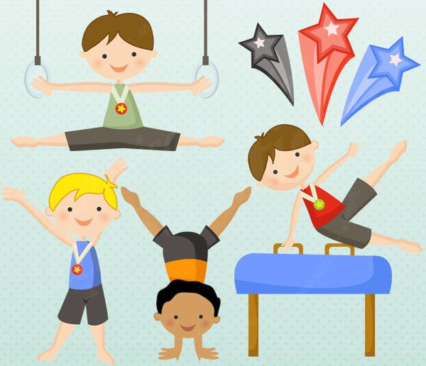

Remember to share your photos and results with us.

