Skipping Challenge

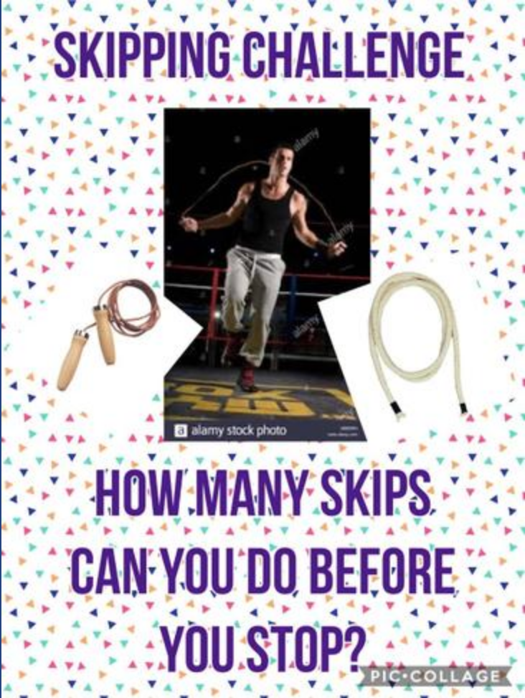

Share your video to be in with a chance of being named our ‘Skipping Champion’.

