Write a newspaper report to explain one of the new inventions created during the Industrial Revolution. | Write a diary entry in the perspective of someone living during the Industrial Revolution or as a factory worker. | Design a piece of clothing that a factory worker would wear (consider working conditions in the design)
Create a protest poster for child labour during the Industrial Revolution | Create a documentary on iMovie explaining what life was like during the Industrial Revolution. | Write a timetable or schedule to show the average day of a factory worker.
Create a collage displaying the changes that occurred between the 18th Century and the 21st Century. | Create 3 Haiku Poems related to the Industrial Revolution. | Create a 3-D model of a factory or factory worker housing.
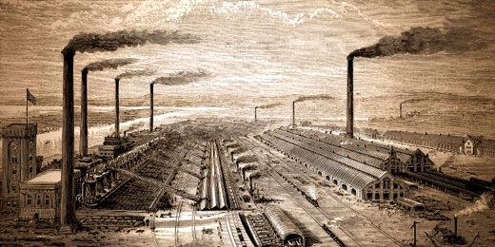
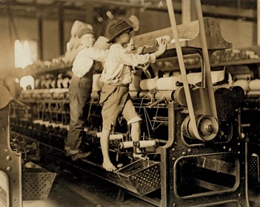

Industrial Revolution
Homework Grid

