Science Task 2

Watch the video ‘Broken’ from 1 minute 3 seconds to 1 minute 10 seconds. You will see Rock plummeting towards the ground at high speed.
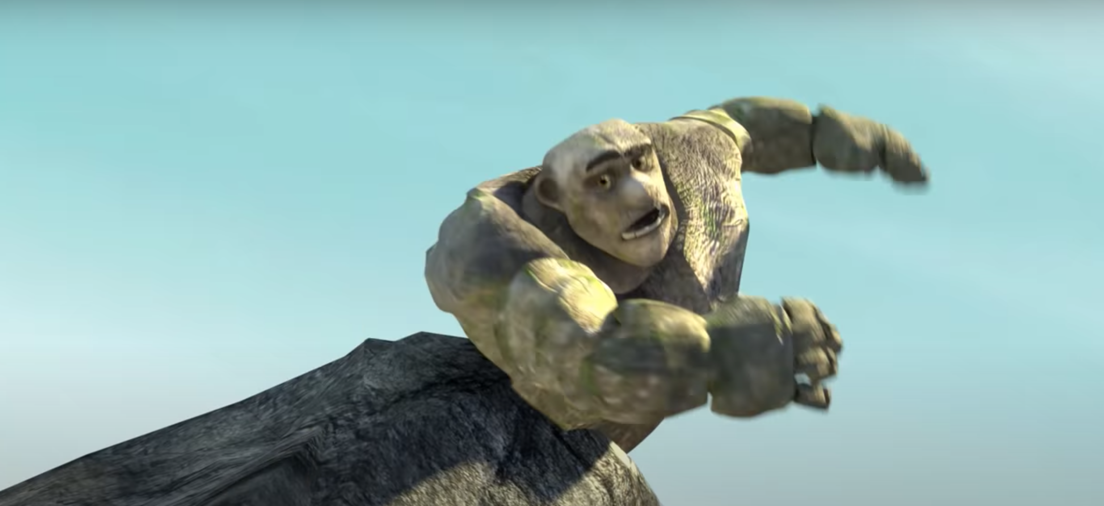

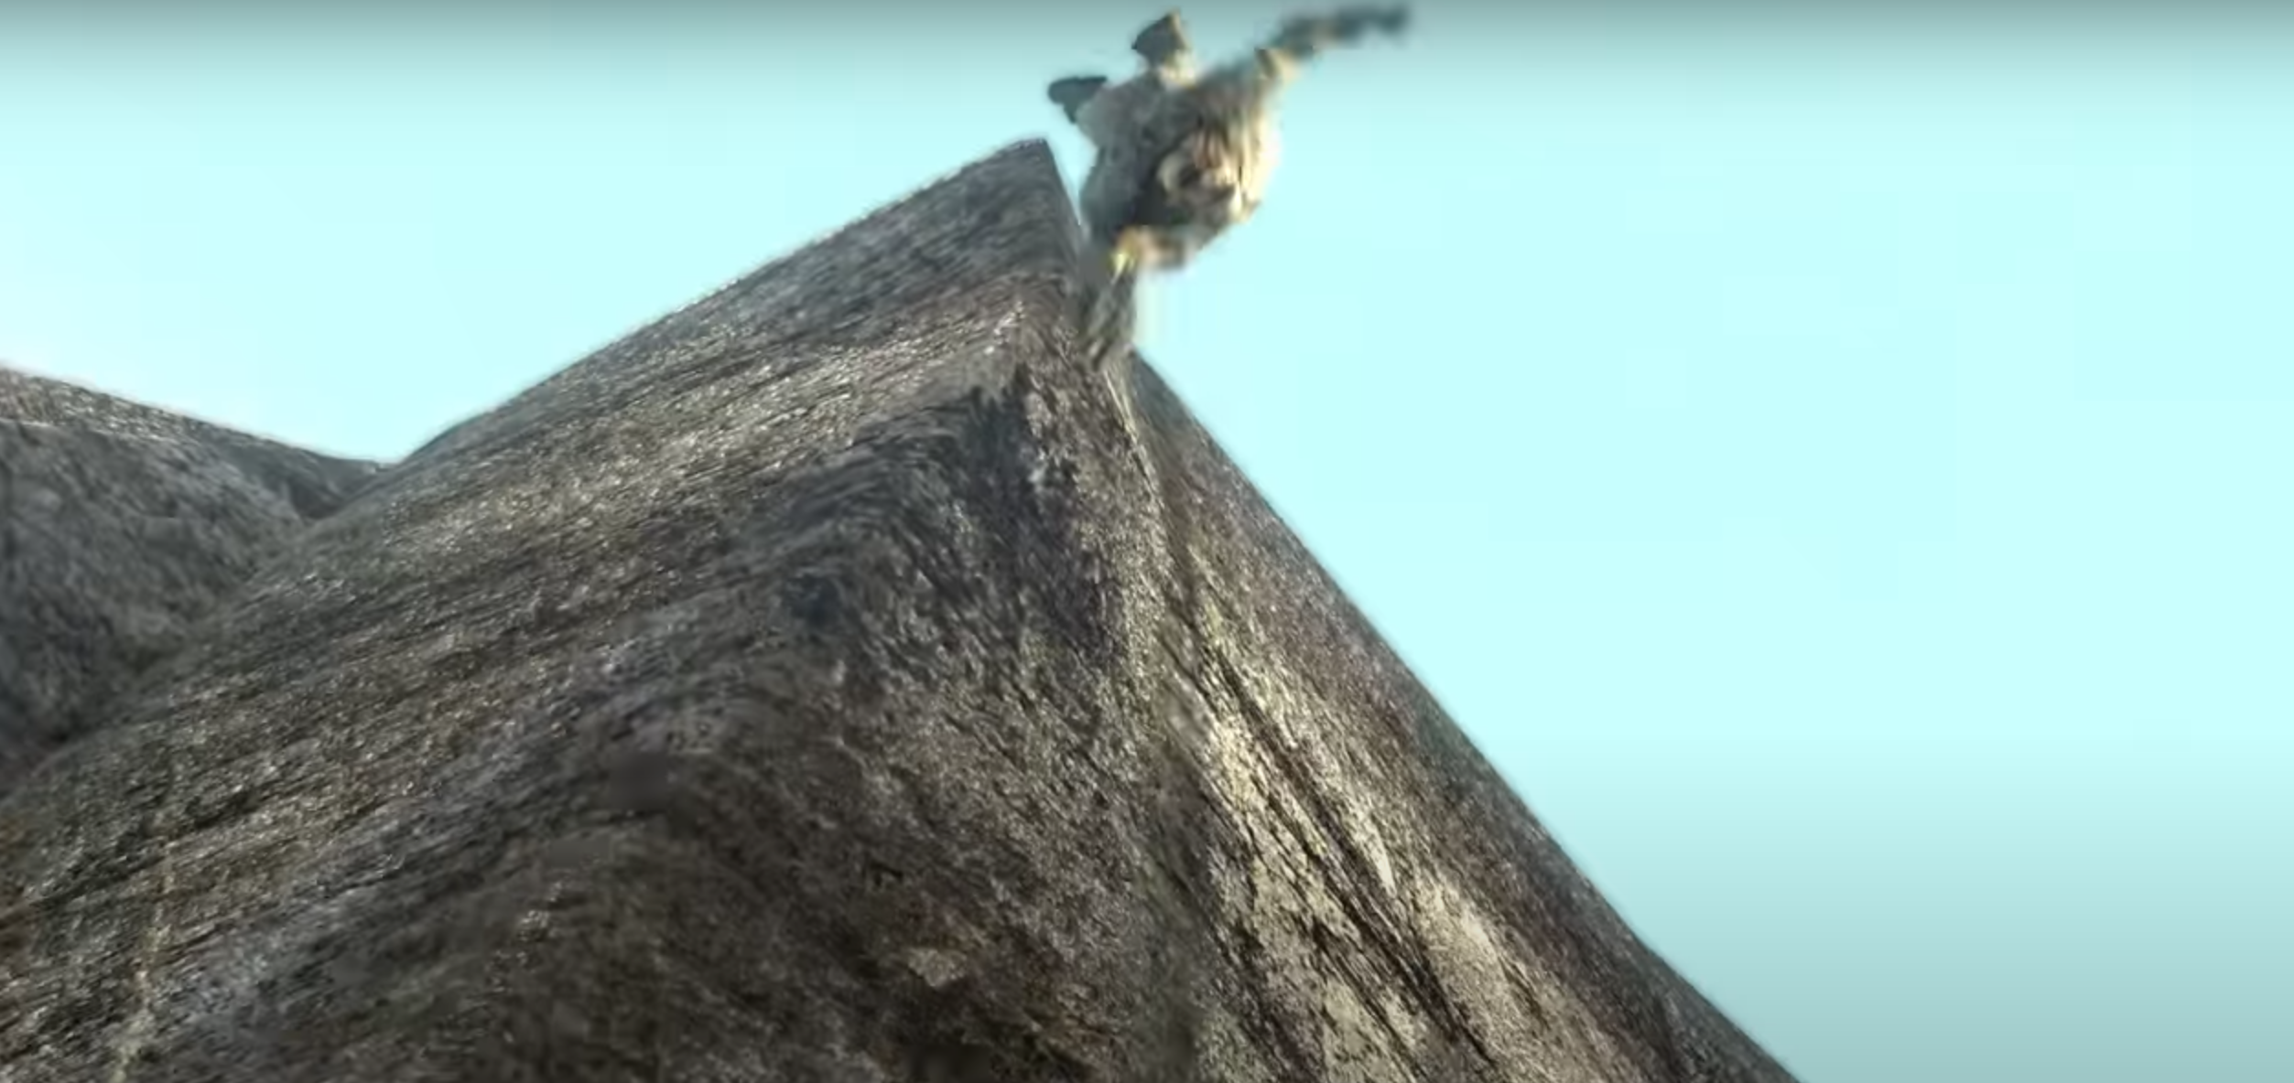

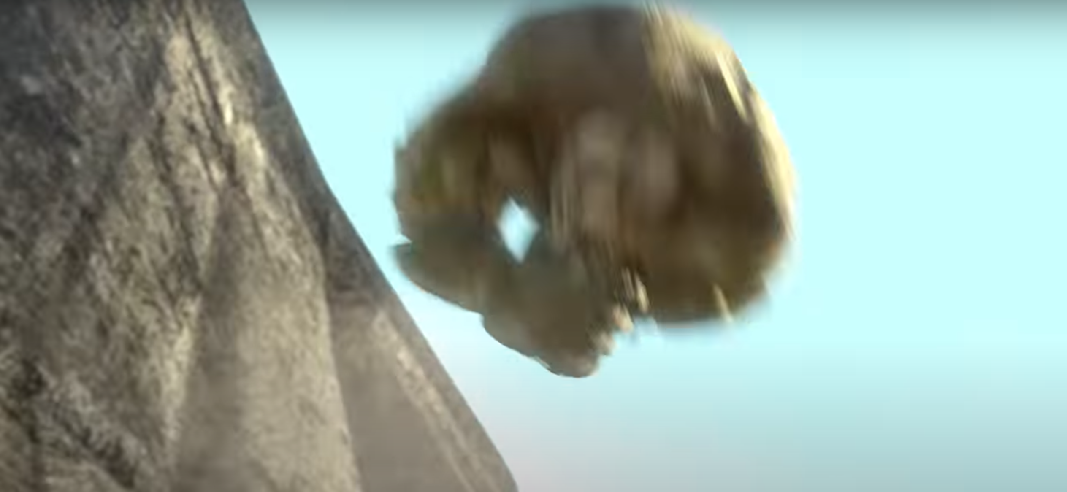

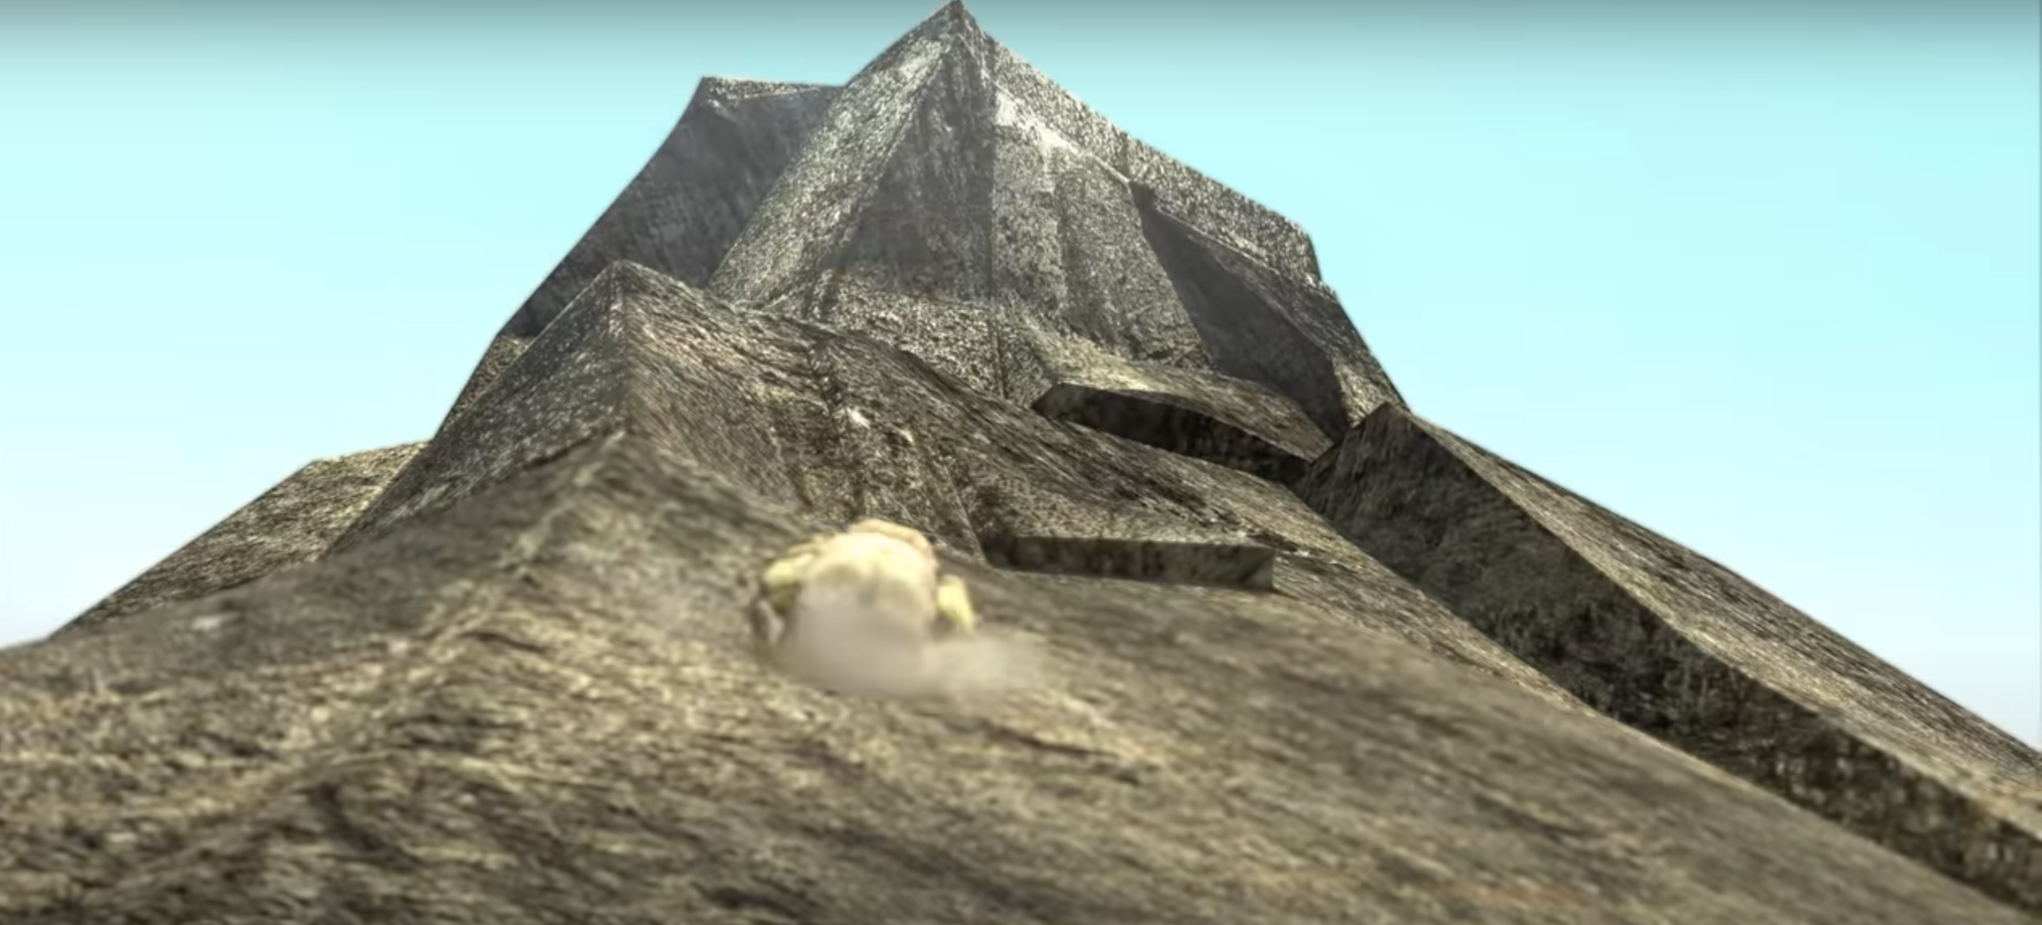

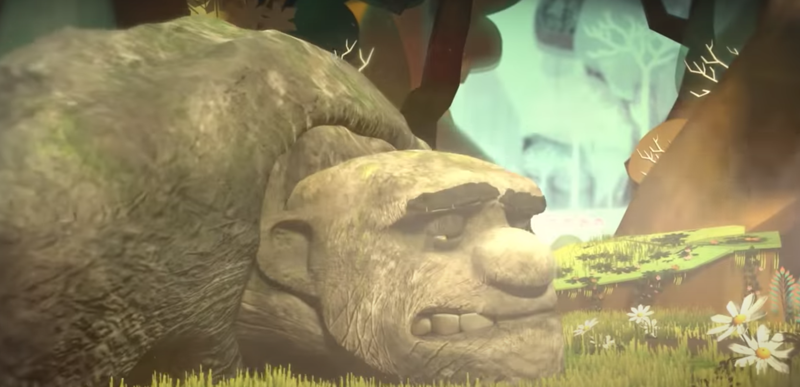

As we know from the video, Rock is quite fragile. Your task is to protect Rock whilst he rolls downhill by creating a layer of body armor.

You will need:
- Three different materials from the following – a plastic bag, paper, cardboard, tissue paper, a piece of cloth, bubble wrap, cling film, foil or any other material that you think would be suitable
- Sellotape or glue
- An egg or several eggs to represent Rock – hardboiled or not (if you’re feeling brave)
- A surface with a sharp decline (to represent the hill). For example, this could be constructed through Lego or a plank of wood/cardboard titled from a surface.

You will need to:
- Use your egg/eggs to represent Rock. Create three separate protective layers of body armor that are made from different materials. Wrap your protective layer around the egg.
- You can choose between rolling your egg down a titled surface or you can drop it from a certain height. Whichever you choose to do, you must do the same for all three of your tests.
- Once you have dropped or rolled your egg, remove your body armor. Then, observe and record the damage that has been caused to your egg. The egg with the least amount of damage clearly has the most effective body armor.

You may wish to record your results using a table, graph, written observations, video or photographs.

