Science Task 1

Watch the video ‘Broken’ from 1 minute 3 seconds to 1 minute 10 seconds. You will see Rock plummeting towards the ground at high speed.
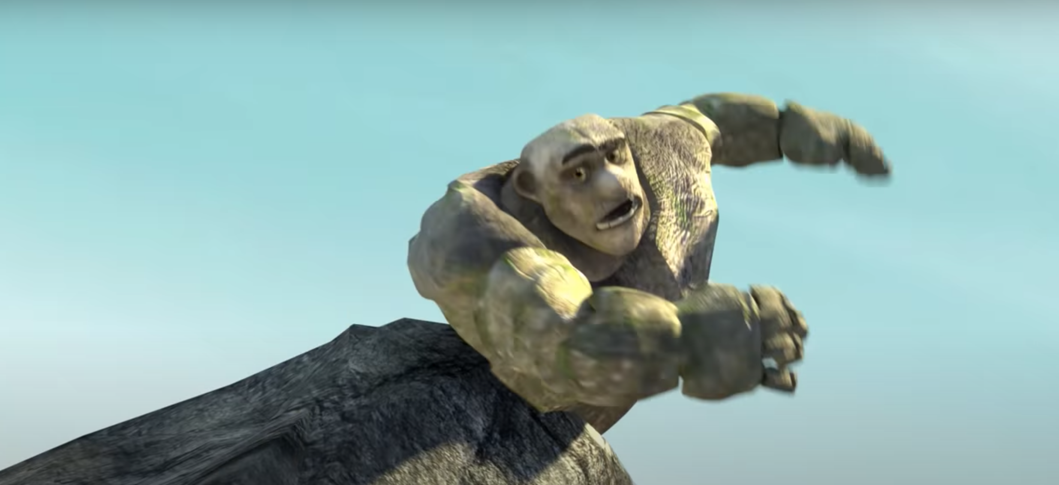

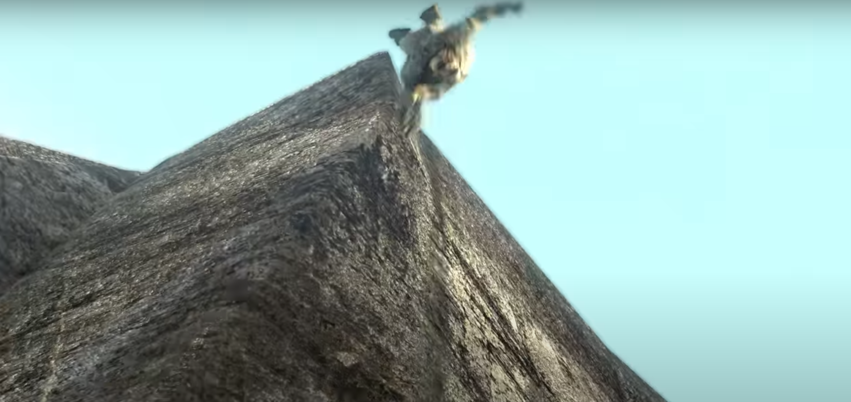

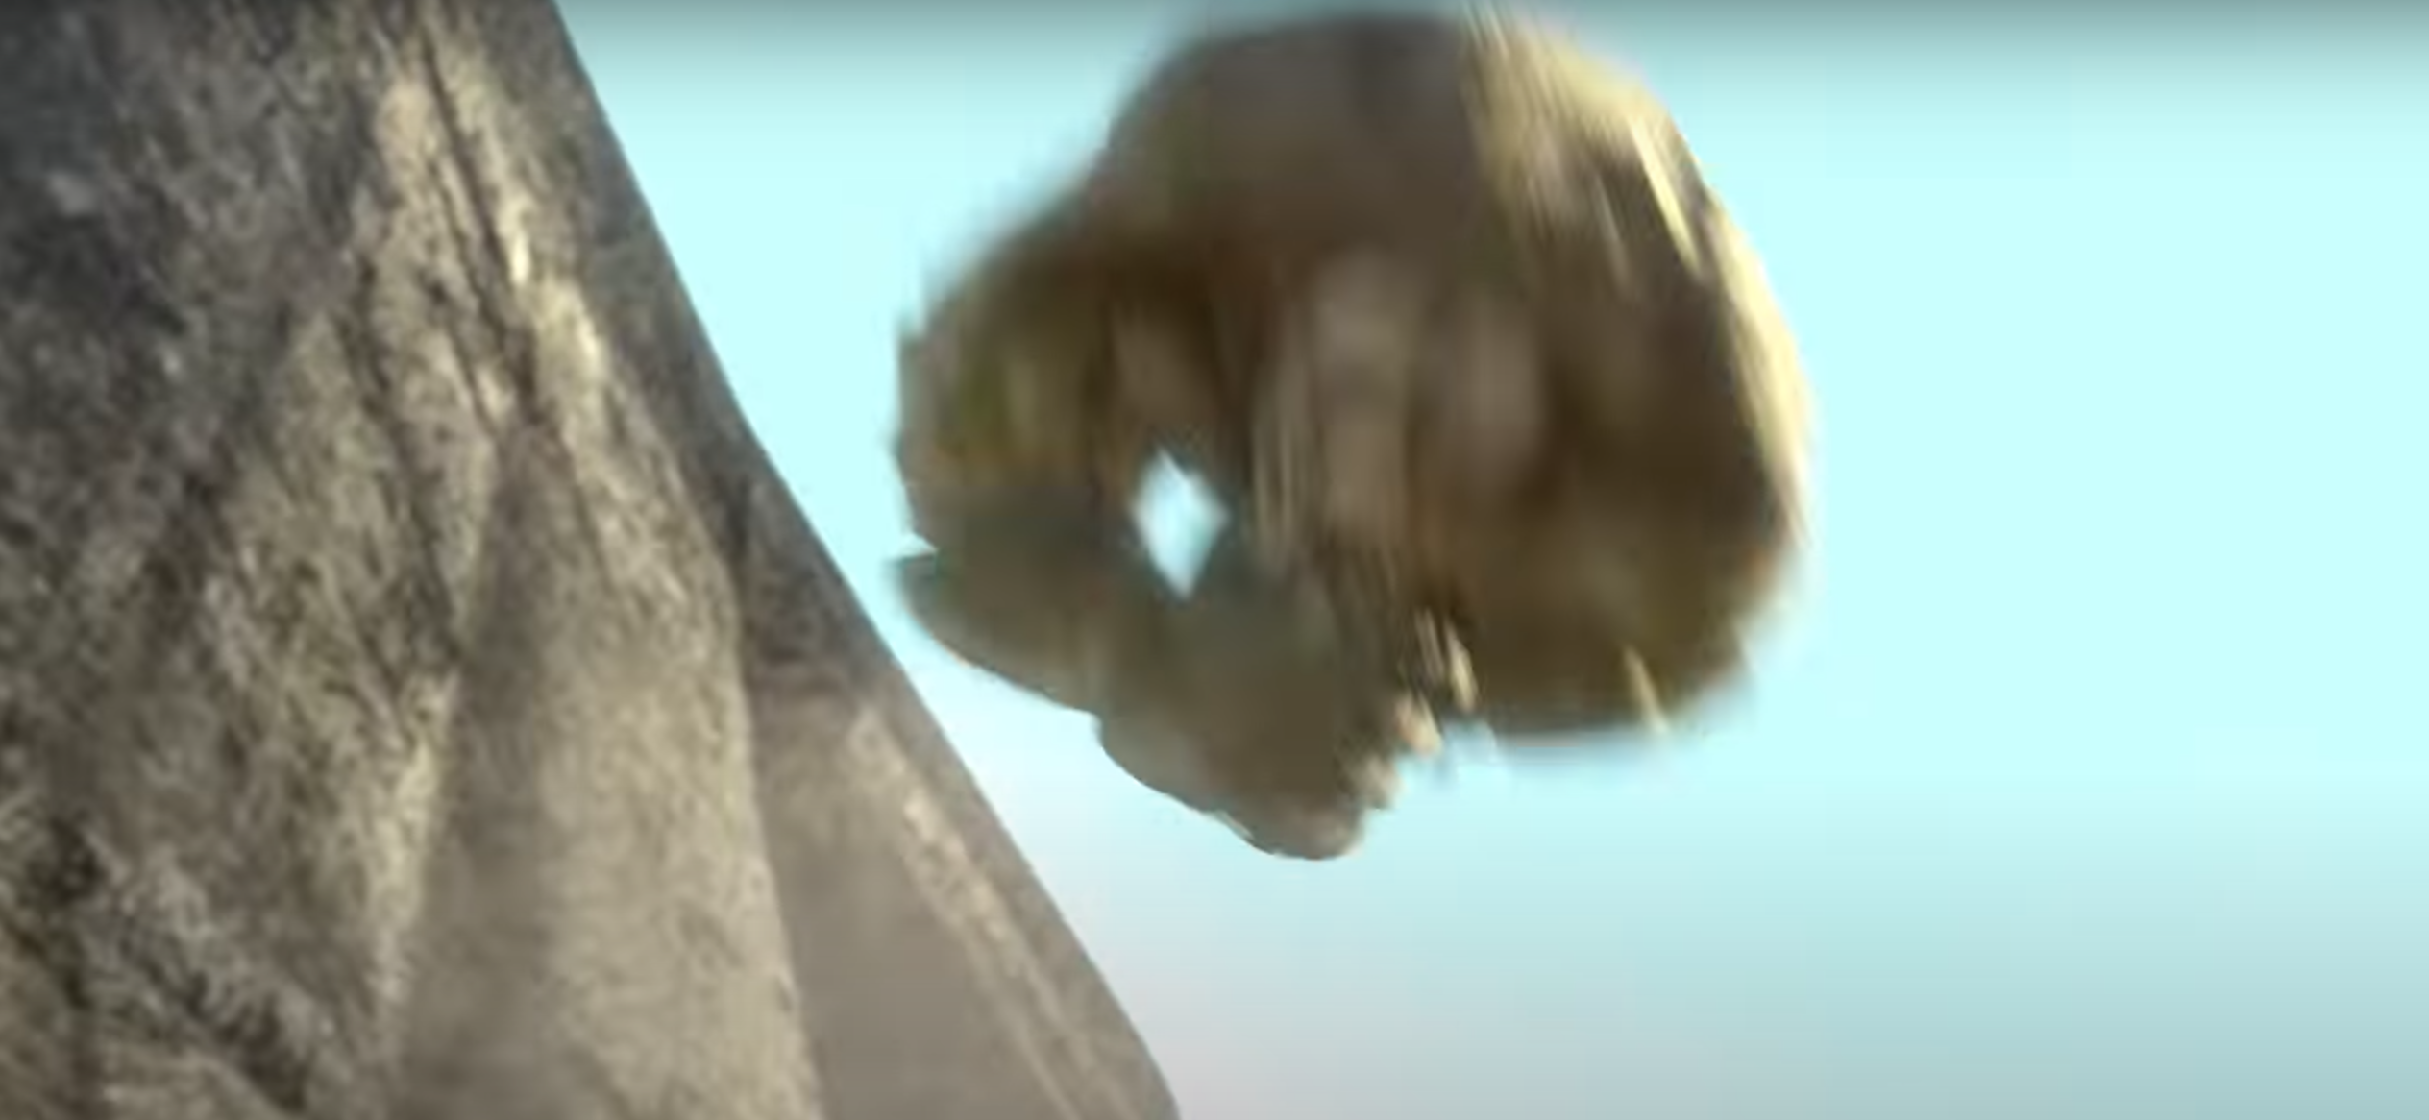

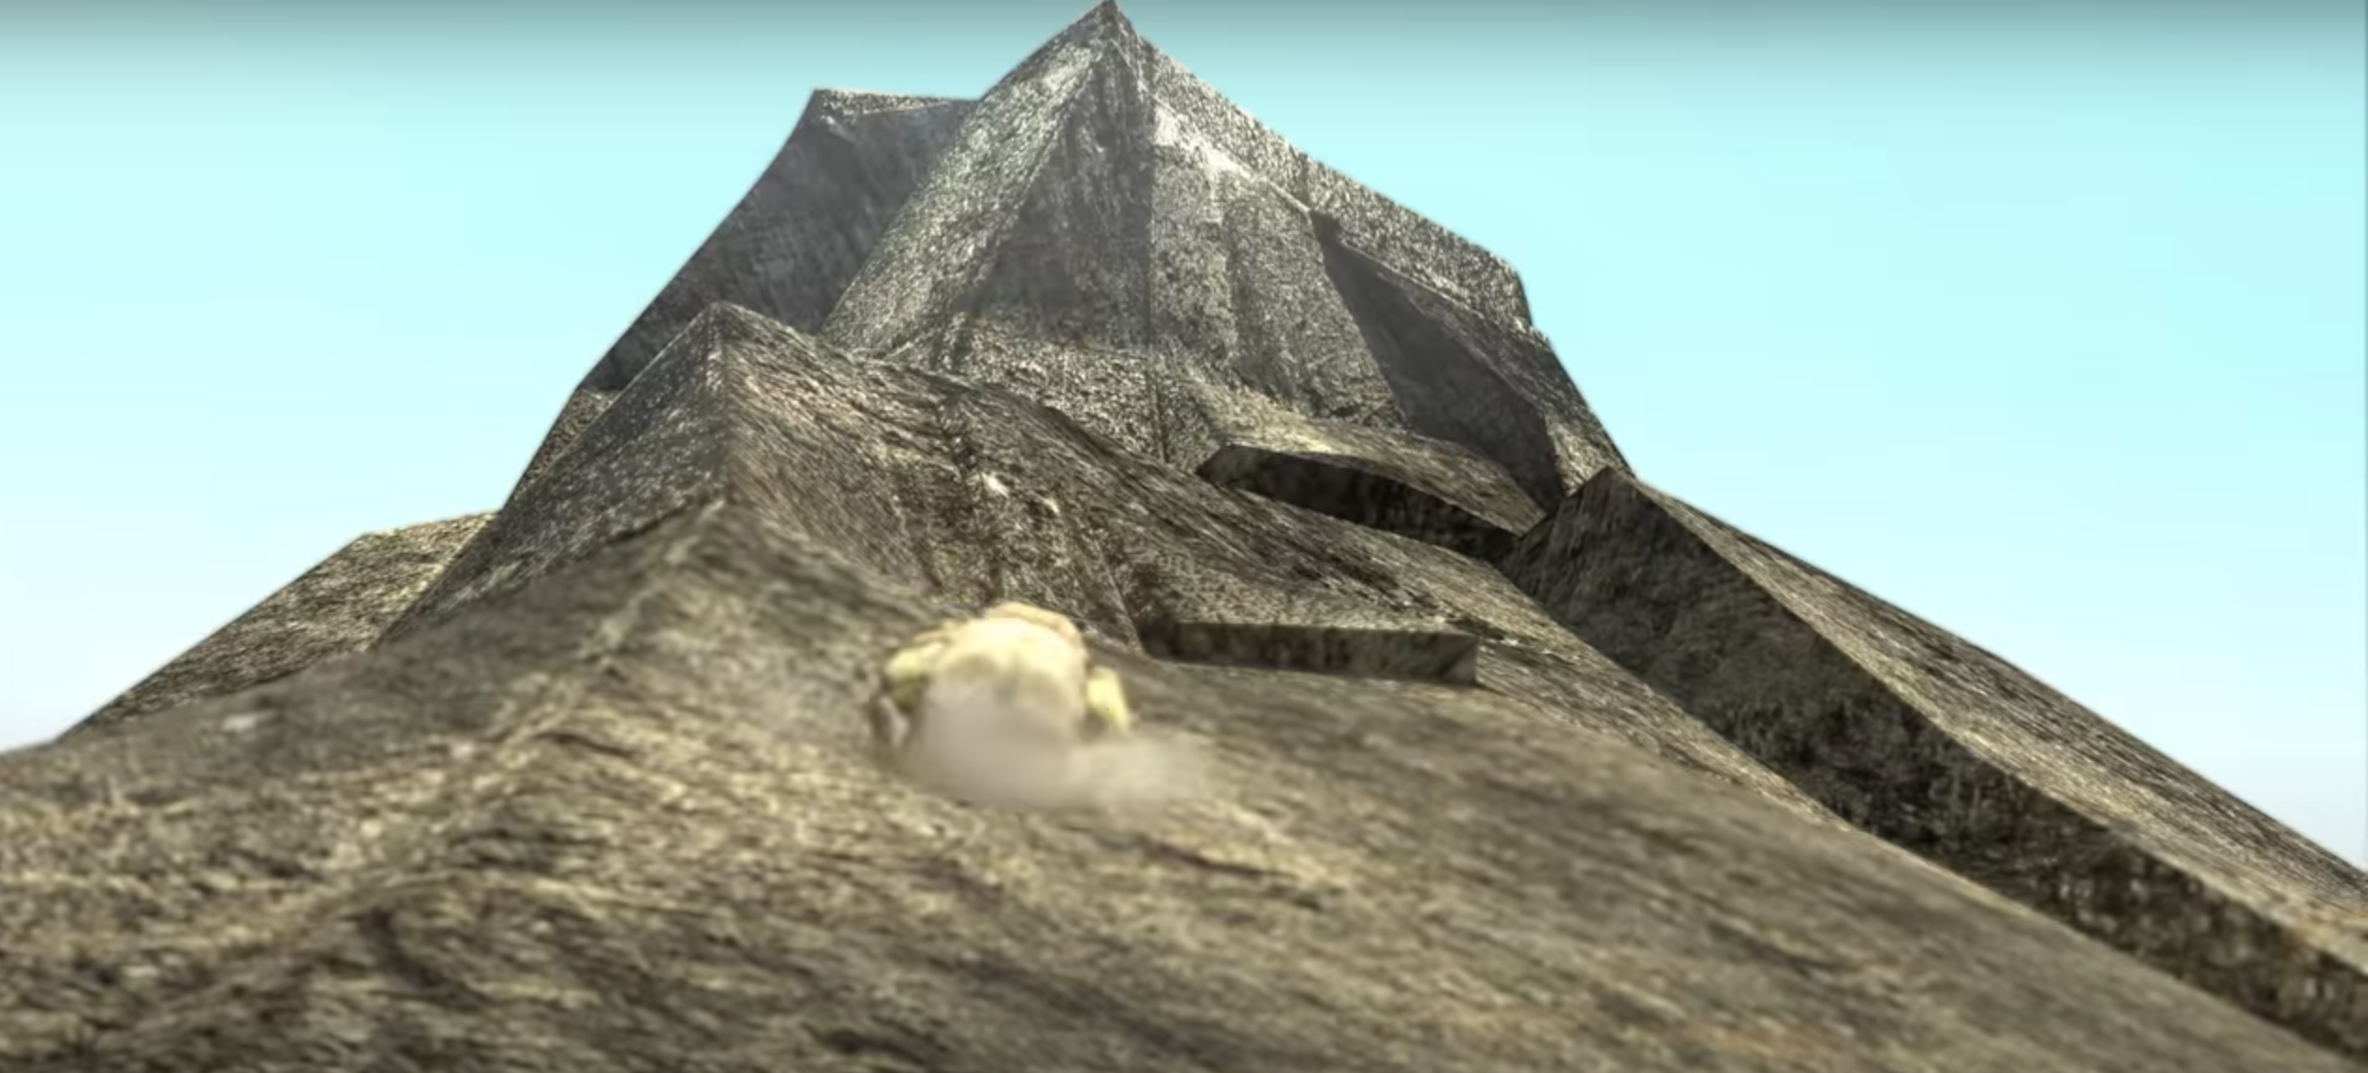

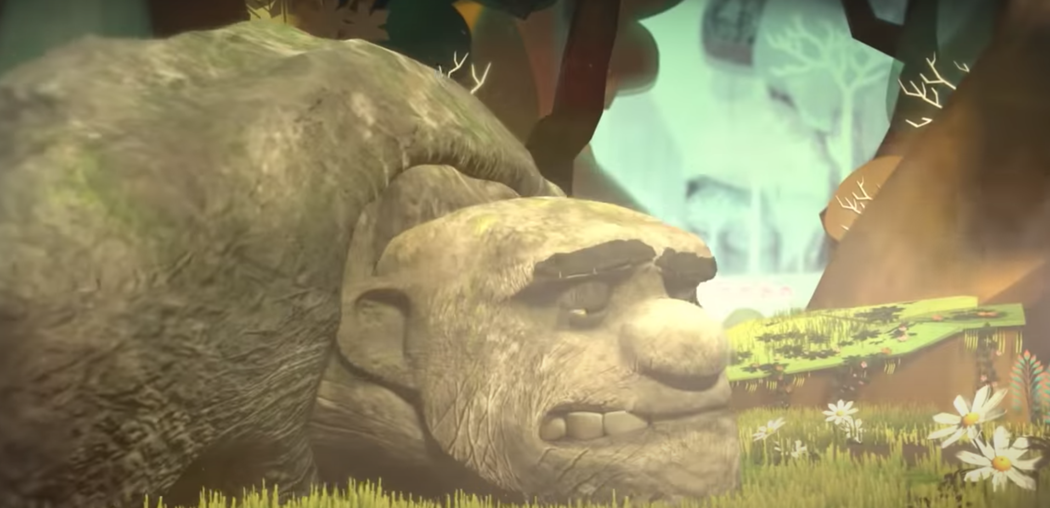

As we know from the video, Rock is quite fragile. Your task is to protect Rock whilst he falls by designing and creating a suitable parachute.

You will need:
- String
- Three different materials from the following – a plastic bag, paper, cardboard, tissue paper, a piece of cloth, or any other materials that you think would work.
- Sellotape, glue or staples
- An item to represent Rock – an actual rock, an egg, a weight, a Lego model

You will need to:
- Create three separate parachutes that are made from different materials but are the same in size.
- Test the parachute by releasing them from the same height each time.
- We suggest that you drop the parachute twice to ensure your results are reliable.
- Make sure you drop the parachute in exactly the same way each time.
- Time the drop of the parachute from the release to when it reaches the ground.
- The most effective parachute will be the one that takes the longest (in time) to reach the ground, due to the amount of air resistance.

You may wish to record your results using a table, graph, written observations, video or photographs.

