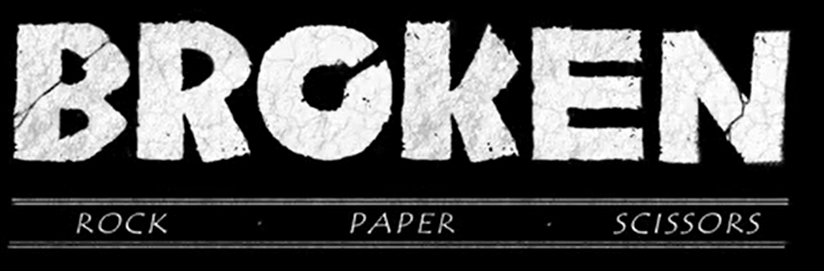

Task 3: Write the story
This week, we would like you to use the same approach that we use in school: writing a part of the story each day. Please focus on the video clip up to 53 seconds.
In this paragraph you will include:
- Setting the scene
- Introduce the character Rock and his habitat
- Introduce the character Paper and her habitat
- Describe the relationship between Rock and Paper

An example
It was simply serene: bursts of colourful life bloomed; the trees stood in awe of the flowers; the warm glowing light glistened through the exquisite foliage. It was blissful. It was picturesque. It was enchanting. Far above the beauty of the forest, the coarse, dry land, absorbed the intensity of the sun. Initially lifeless, the bare and drab terrain was interrupted with a glimmer of life. One sharp-edged rock fell, followed by another, to reveal a downcast spirit. Breaking free from his restraint, he crawled forward eager to capture a glimpse of the elegance below. As he peered off the cliff, he was memorised by a dainty, delicate creature – who appeared to be gliding from flower to flower. Rock’s eyes were fixated on Paper like an aspiring astronomer star gazing for the very first time. Unaware of her admirer above, she tending to her striking friends (the flowers).

