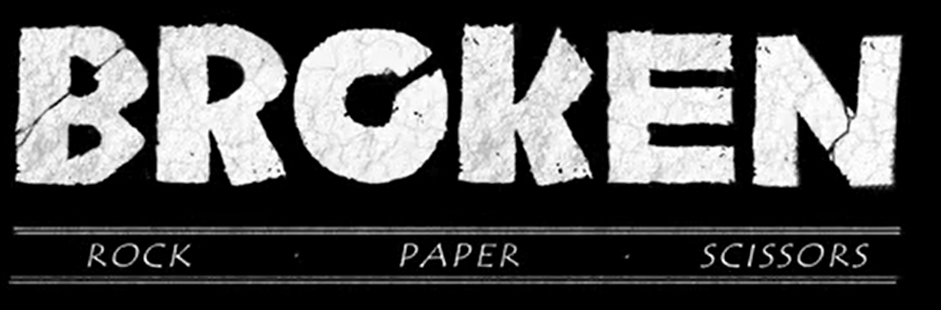
Before you watch the video, what do you think the film could be about from the title?
Play a game of ‘rock, paper, scissors’ with a family member or friend. If this was a story who would win a battle?

Task 1: Reading Comprehension
Play the film and pause it after 20 seconds.
- Which character do you think this is?
- Can you think of any adverbs to describe how he moves?
- Use similes or metaphors to describe his appearance.

Pause the film after 52 seconds when Rock rests his head on his arm.
- Who is Rock watching?
- Describe how Paper is moving.
- What does Rock think about Paper?

Pause after 1 minute
- How does the director use music and sound to signify danger?
- How could we get the same effect in our writing?

Pause the film on the close up of Scissors’ face
- How could we describe Scissors’ face?
- Use similes or metaphors to enhance the description of his angular features.

Pause the film at 1 min 25 when Rock grips Paper’s arm.
- If he could speak what do you think he would say to her now?
- What punctuation would we need to use to write it down.
- Play the next couple of seconds and asks why can’t he hold on to Paper’s arm?

Pause the film at 2min 23 secs when Scissors is marching towards them.
- Based on the traditional game can children make predictions what will happen?

Pause the film at 3 min 07 secs when Rock is stood over the lifeless Paper.
- How did Rock feel when he vanquished Scissors?
- How does he feel now?
- How might an author show this in their writing?

Pause the film at 3 min 18 seconds. When Rock’s hands first crumble at her touch.
- What can Rock not do?
- How will he help her?
- Will he help her?
- What would you do if you were Rock?

Pause the film at 3 min 44 secs when the sun hits Paper’s face.
- What has happened?

At the end of the film
- What has happened?
- Were you right or wrong?
- How does Paper feel about Rock?
- Do you think Rock regrets his actions?

