Kandinsky Inspired Art
For this activity you will study the art and life of Kandinsky, a talented Russian artist and musician. You will also make an oil pastel picture of circles in squares while listening to Kandinsky music.
Resources:
- A piece of A3 or A4 paper (Poster paper would be even better!)
- oil pastels or colouring pencils
- a variety of Kandinsky music (please see links 2 & 3)
- Kandinsky images that will help inspire you (links 2 & 3)

Learning Objectives:
- Research the famous visual artist Wassily Kandinsky and how he was also a talented musician. You could create a fact file page or a PowerPoint to show the information you have found. (Link 1)
- Create your circle art using concepts of colour and how it relates to our emotions. Examples: What emotion do you associate with red? (anger, embarrassment etc.) What emotions do you associate with blue? (sadness, loneliness, calm) What emotions do you associate with yellow? (happiness, contentment, warmth) etc.
- Fold your sheet of paper into six squares. Listen to a variety of music and create circular colour studies (in each section) based on how the music makes you feel.
- Once these are complete, keep them safe for our return to school. We can display and celebrate them in our shared area.

Some facts to get you started with your research:
Type of Work: Painting
Born:1866
Died:1944
Nationality: Russian
Style/Movement: Blaue Reiter (The Blue Rider); Bauhaus
Best Known For: Founding the group the Blaue Reiter and connecting art with music and spirituality.
Important Works: Composition IV, 1911 & With Black Arch, 1912

Links:
- 10 Amazing facts about Kandinsky - https://www.youtube.com/watch?v=AaviUsz2r9M
- Music – Composition VIII - https://www.youtube.com/watch?v=aWjRlBF91Mk
- Music – Concerto 23 - https://www.youtube.com/watch?v=4nZ_qkeffY4
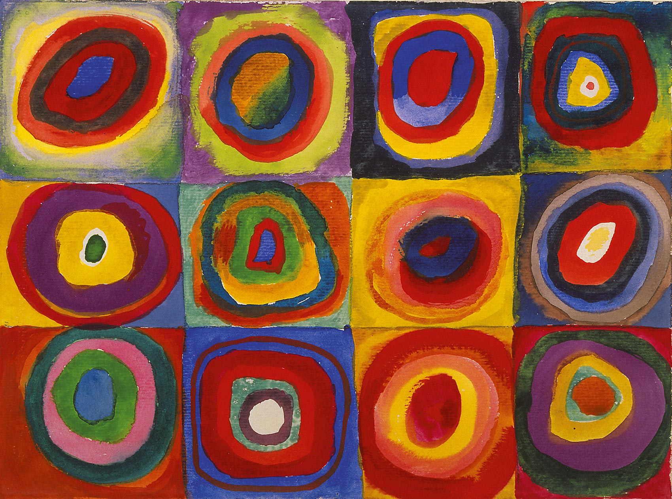

Keep up the fab work Year 5 & 6! You are doing an incredible job. We are really proud of you and can’t wait to see your wonderful creations.

