Art Inspired by Atlantis

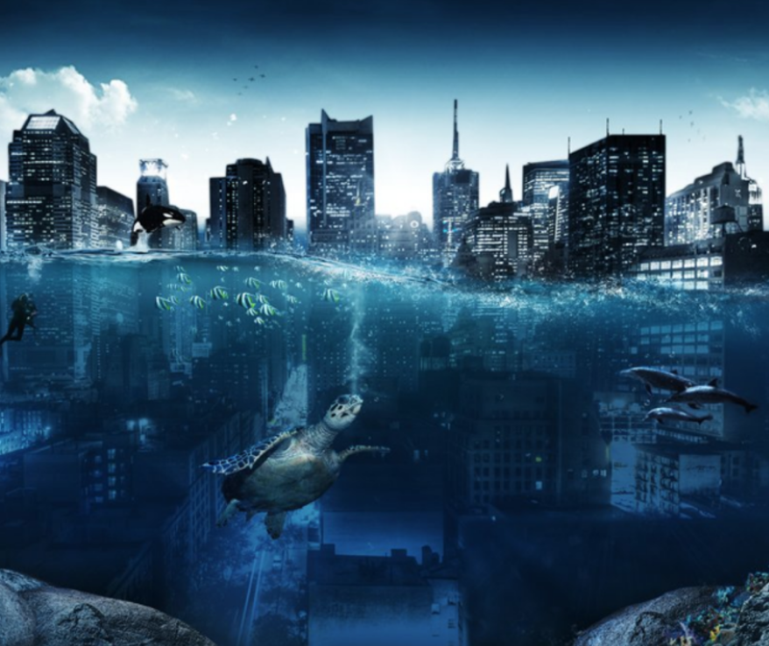

Perfect Picture!
Imagine your school was underwater.
Draw or describe what one of your lessons would look like.

