The Forbidden Tower
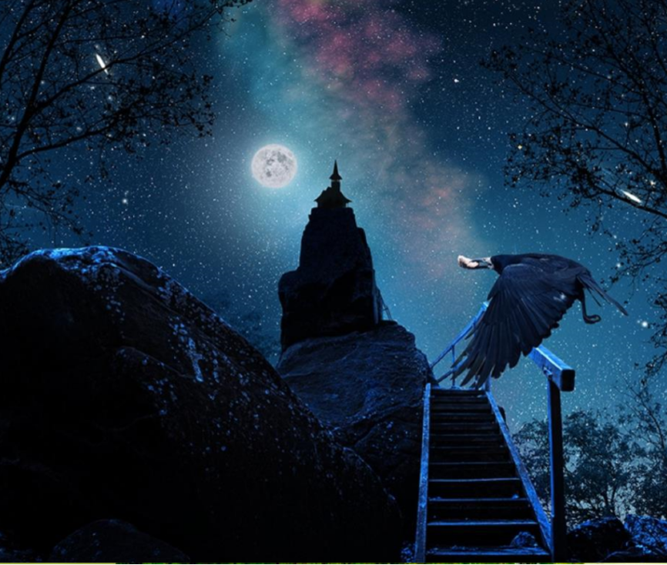
Now that you have chosen your picture, you have the choice for your genre.
- Setting Description
- Story – either writing your own or completing a story from the a story starter
- Diary Entry (from the bird’s perspective)

Task 1: Question Time
- If you were in front of the tower, would you enter?
- How does the time of day change the mood of the story?
- How does this change the impact of the story upon the reader?
- What is difference between a silhouette and a shadow?
- Why do you think that there is a hint of pink in the sky?

Task 1: Vocab Collection
Use the target below to gather vocabulary that can be incorporated into your piece of writing. Think about:
- Adjectives to form expanded noun phrases
- Powerful verbs
- Figurative language (similes, personification, metaphors, alliteration, onomatopoeia)
Once you have your initial ideas, think carefully about where you place them onto the target. Place your most powerful ideas in the centre of the target, and the ideas that still require improvement (pink polished), place around the edge.
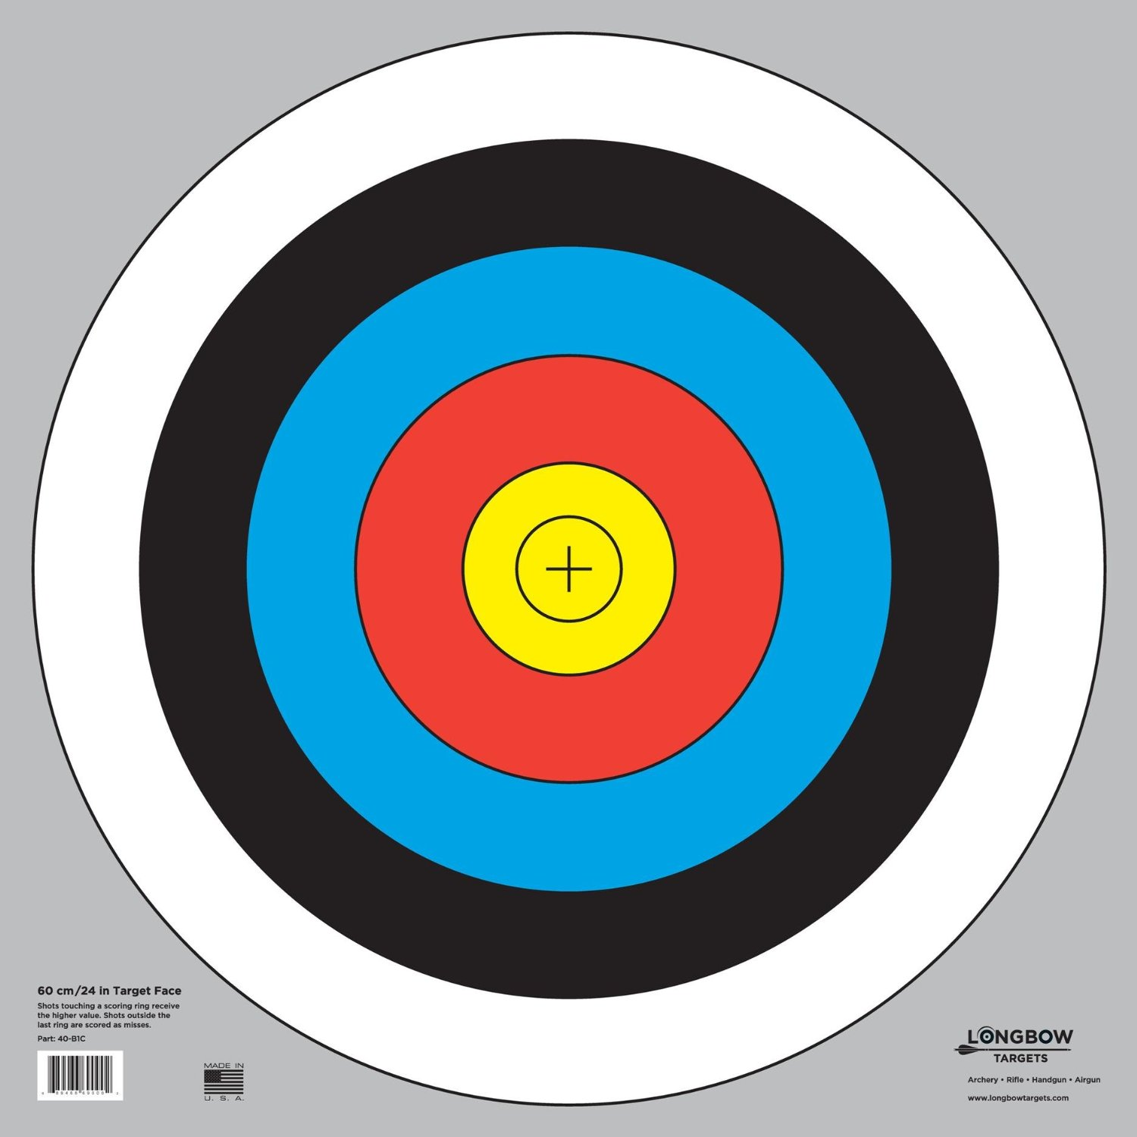
Dark
Gloomy
Eerie, Foreboding
Murky
Mysterious

