Atlantis
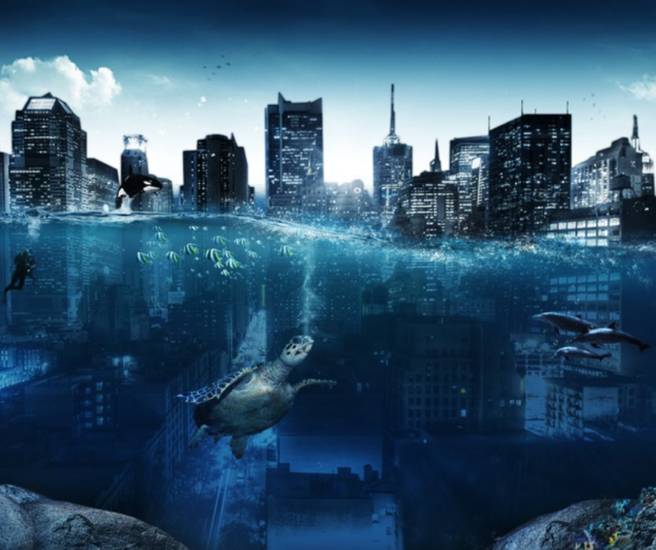

Task 2: Sentence Challenge
Can you write four sentences based on the picture that include a subordinate clause? Think about varying the position of the subordinate clause each time.
Y6 GD: Can you write two sentences using two subordinate clauses and a main clause in each one?
Now think about your compound sentences, can you use one of the following conjunctions to link your clauses together: but, or, yet, so?
e.g. This had once been a populated place, but now everything had changed.

Task 2: The Main Write
Remember that you can you can choose one of the genres below.
- Setting Description
Think carefully about:
- Incorporating the five senses
- Using figurative language for description

- Story – either writing your own or completing a story from the a story starter

Example
The water was rising. Soon, everything would be underwater. The thousands of lights that sparkled against the dark backdrop of the colossal skyscrapers were being extinguished one by one, as the monstrous buildings were gradually disappearing under the dark tides; banished to a watery grave beneath the lonely depths. Nobody knew what had caused the great flood. There had not been time to stop and think.

- Diary Entry (from either a sea creature’s perspective or the scuba diver’s perspective)
Think carefully about:
- Incorporating thoughts and feelings
- Using the past tense
- 1st person

