Research a list of interesting facts and major events that happened in 1874. | Write a diary entry in the perspective of someone living in Seighford in 1874 after their first day at a new school. | Design a school uniform that children would wear in 1874(consider fashion at the time in your design)
Create a poster with a factfile about the life of Edwin Cooper Perry. | Create a documentary video explaining what life was like for children in Victorian Britain. | Draw and paint an artwork of St Chad’s Church.
Create a collage displaying the differences between school life in 1875 and 2025. | Create 3 Haiku Poems about being a child at Cooper Perry. | Create a 3-D model of what you imagine Cooper Perry school might look like in 50 years time.
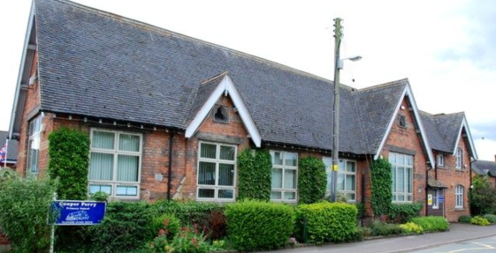

150 Years of Cooper Perry
Homework Grid

