Thursday 22nd February 2024

I can identify risk in a range of situations.

Find the hazards in the picture below.
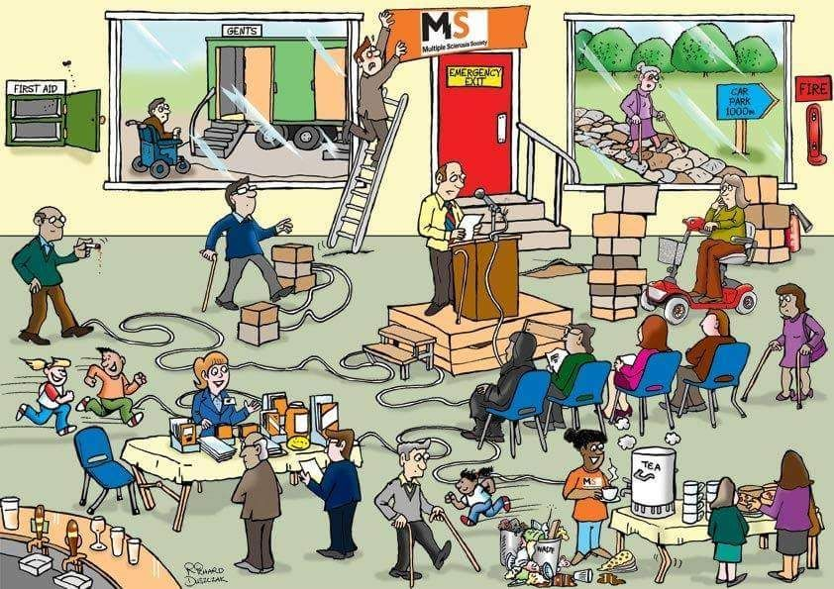
What can you do to avoid risks?

Do you ever need help from an adult?

Create your own poster to show the hazards in a given situation (e.g. being near the road, being near water, in the kitchen.) and explain how we can avoid these ricks.

