Collage a map of Peru – can you locate Lima the capital city? What about Machu Picchu? Or other landmarks? | Learn how to say hello in Spanish! Can you count to 10? What else could you learn to say? | Can you make your own set of panpipes? And can you play them?
What food is traditionally eaten in Peru? Find out and cook something.  If you like you can bring it in to share with the class. | Make a poster about Peru | Can you find out about any famous people from Peru?
What currency is used in Peru? Can you create a guide, maybe even comparing it to the currency we use? | What animals are found in the wild in Peru – do any of them live in the wild here? | Listen to some Peruvian music and learn a traditional dance – why don’t you video yourself and email it in?
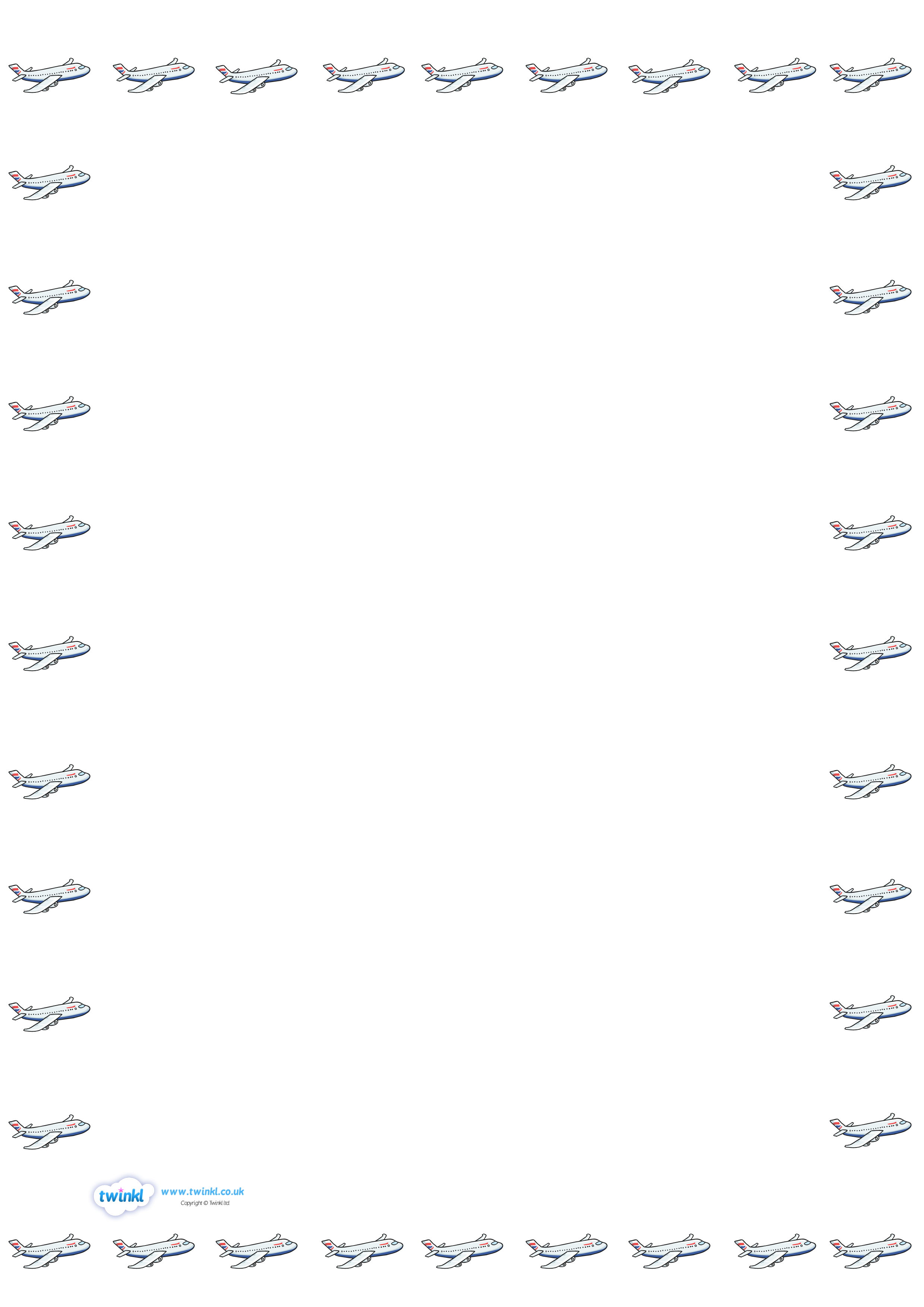
Are all our lives the same?
Worlds Apart: comparing life here with life in Peru.
We are exploring how life here compares to life in Peru. These tasks are designed to help extend our learning at home. Please pick at least 2 pieces of homework, and bring your homework into school throughout the half-term.

