Topic fact sheet – Worlds Apart
Are all lives the same?
Key terms:
Peru is in South America.
Spanish is spoken in Peru.
31.99 million people live in Peru.
The Vicuna is their national animal – can you find a picture of one?
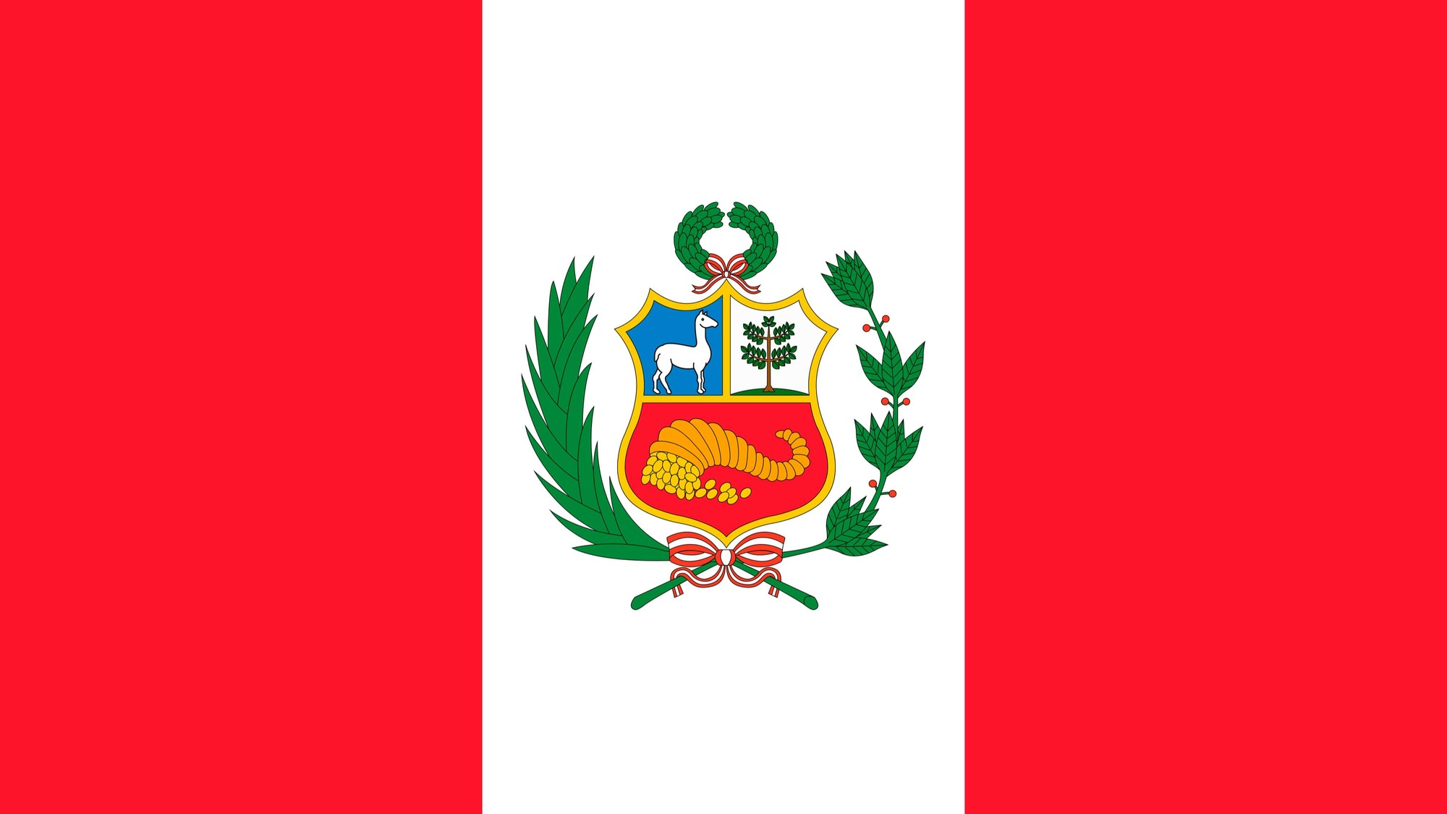

Compare | Looking at what is similar and different.
Map | A drawing of all or part of a surface to show where things are.
Globe | A round model of the earth used like a map.
Position | Where something is.
Location | A place or settlement.
Landmark | Something that is easy to see.
Observation | Watching, listening and asking questions.
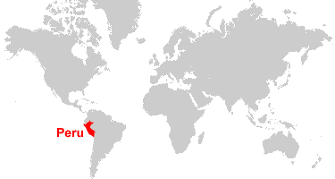

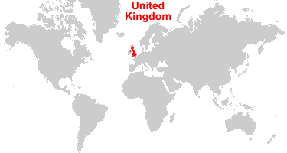
The United Kingdom is in Europe.
English is spoken in the United Kingdom.
66.65 million people live in the United Kingdom.
The United Kingdom’s coat of arms features a lion and a unicorn.


