

Task 3

Before you move on to your main write, use the images below to gather vocabulary to describe the setting, the characters and the main aspects of the story.
Think about –
- Expanded noun phrases
- New vocabulary – use of a thesaurus
- Similes
- Metaphors
- Personification
- Powerful verbs
- Adverbs
The washing stood motionless in the night sky
calm

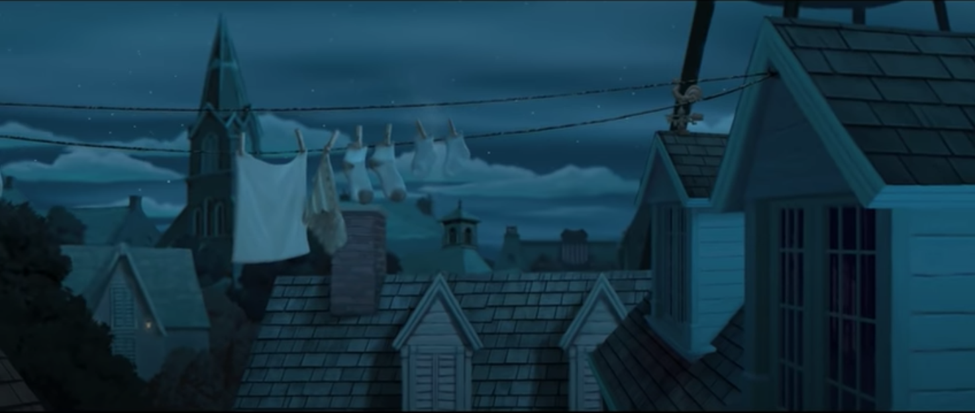

The silence filled the air



