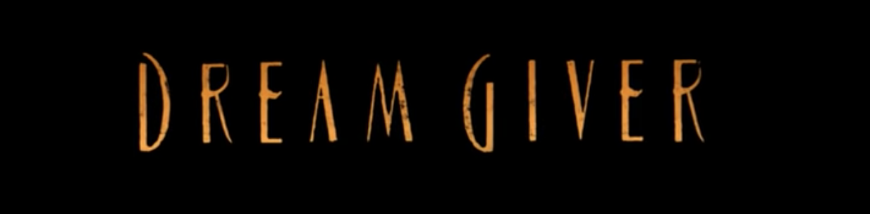

Task 2

Use the images below to help you sequence the main events in the video.
Annotate the pictures to explain the key aspects of the story – we have done the first one for you.

- It’s the middle of the night and all is calm.
- A mysterious character appears at the window of an orphanage.
- He is holding a glowing bag – what could be inside?
- He seems to be there for a purpose
- A room of children are fast asleep


