Reading

- Have we experienced Paddington’s adventures?
- Can we relate to Paddington’s feeling on his adventures?
Writing

- Paddington’s life in Peru compared to England
- Is the King’s life the same as ours?
- Comparing Aunt Lucy’s life to Paddington’s in England.

Worlds apart
Are all lives the same?

PSHE

- Do all children have a voice?
- What is school life like for children in Peru compared with England?
- Can we relate to Paddington’s feeling on his adventures?

Art

- Does everyone access to the same art resources?
- How does art vary within countries and cultures?
- Create art work inspired by Peruvian culture.
RE

- Christian text: Noah’s ark.
- Islamic text: The Crying Camel

Comparing the aspects of lives within Christian and Islamic faith.

Maths

Place Value:

Step 1 Numbers to 20

Step 2 Count objects to 100 by making 10s

Step 3 Recognise tens and ones

Step 4 Use a place value chart

Step 5 Partition numbers to 100

Step 6 Write numbers to 100 in words

Step 7 Flexibly partition numbers to 100

Step 8 Write numbers to 100

Step 9 10s on the number line to 100

Step 10 10s and 1s on the number line to 100

Step 11 Estimate numbers on a number line

Step 12 Compare objects

Step 13 Compare numbers

Step 14 Order objects and numbers

Step 15 Count in 2s, 5s and 10s

Step 16 Count in 3s
Addition and subtraction:

Step 1 Bonds to 10

Step 2 Fact families

Step 3 Related facts

Step 4 Bonds to 100 (tens)

Step 5 Add and subtract 1s

Step 6 Add by making 10

Step 7 Add three 1-digit numbers

Step 8 Add to the next 10

Step 9 Add across a 10

Step 10 Subtract across 10

Step 11 Subtract from a 10

Step 12 Subtract a 1-digit number from a 2-digit number (across a 10)

Reading

Book:
- Paddington’s suitcase books

Word reading:
- Continue to apply phonic knowledge and skills as the route to decode words
- Read accurately by blending the sounds in words that contain the graphemes taught so far
- Read aloud books closely matched to their improving phonic knowledge

Comprehension:
- Didiscuss the sequence of events in books and how items of information are related
- Become increasingly familiar with and retelling a wider range of stories.
- Check that the text makes sense to them as they read and correcting inaccurate reading
- Make inferences on the basis of what is being said and done

VIPERS reading scheme:
- Vocabulary
- Infer
- Predict
- Explain
- Retrieve
- Sequence
Writing

Postcard to Aunt Lucy in Peru:
- Correctly demarcate sentences
- Identify nouns
- Correct use of past tense

Character description:
- Identify adjectives
- Use the conjunction ‘and’
- Compound words

Story: Paddington’s adventure at the…
- Expanded noun phases
- Use the conjunction ‘but’
- Suffixes
- Identify verbs

Diary entry:
- Expanded noun phrases
- Use of question marks
- Suffixes

Autumn 1

Science

Animals including humans:
- Life cycles
- Basic needs
- Diet
- Exercise
- Hygiene

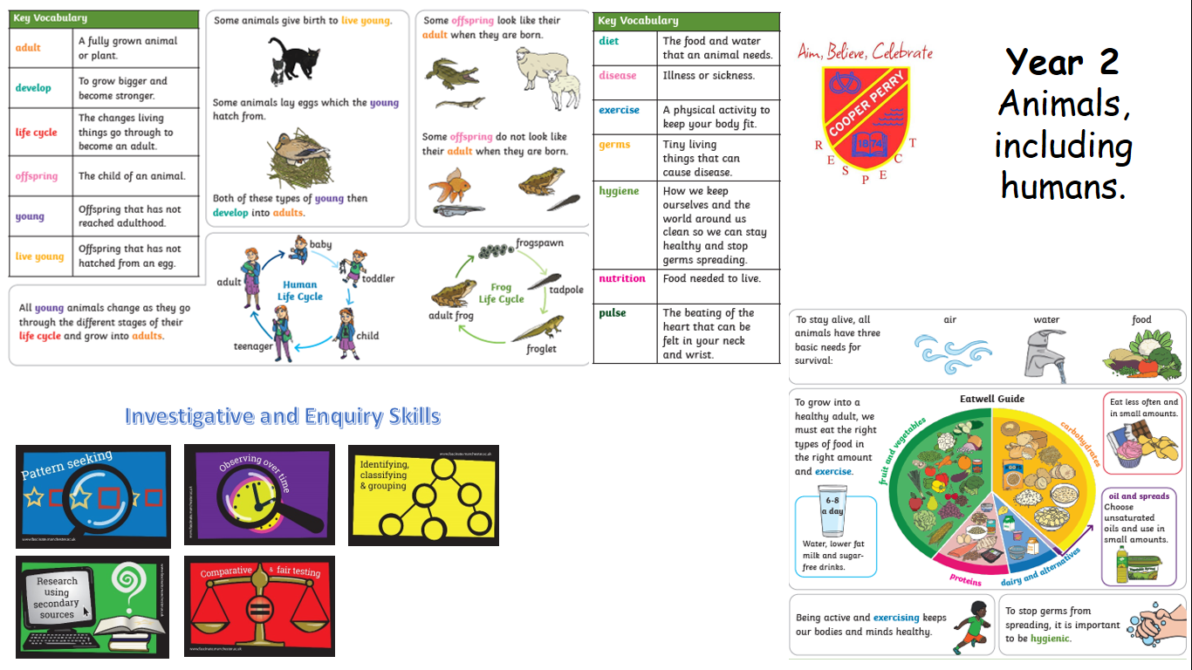
RE

Caring for the natural world
Key questions:
- Who cares for the environment?
- How can we care for our environment?

Christian text: Noah’s ark.
Islamic text: The Crying Camel

Vocab:
Christianity
Islam
Bible
Qur’an
Prophet
Sacred
Natural World
Responsibility

Art/DT

Artist:
- Victor Delfin (Peruvian Artist)

Skill Focus:
- Observe Victor’s work
- Mixing primary and secondary colours
- Adding materials to paint to create texture
- Create a painting inspired by Victor’s work.

Medium:
- Paint
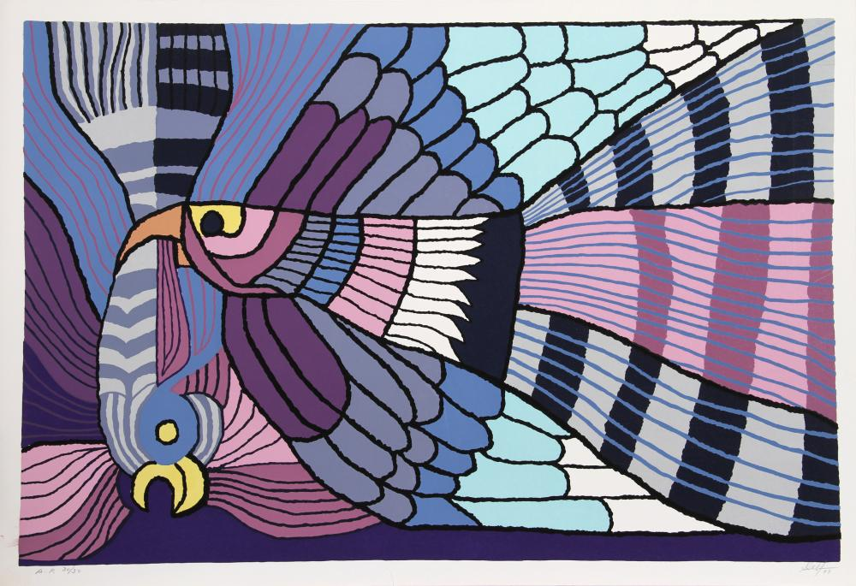

PSHE

Me and My School

Class rules
- Why do we have rules?

School Council
- How it works
- Role of a representative
- Class council meeting

Feelings
- Name feelings
- Dealing with feelings including negative ones

No Outsider link:
- To be able to work with everyone in my class
Computing

Computer systems and networks – IT around us

- What is IT?
- IT in schools
- IT in the world
- The benefits of IT
- IT safety
- Using IT in different ways.

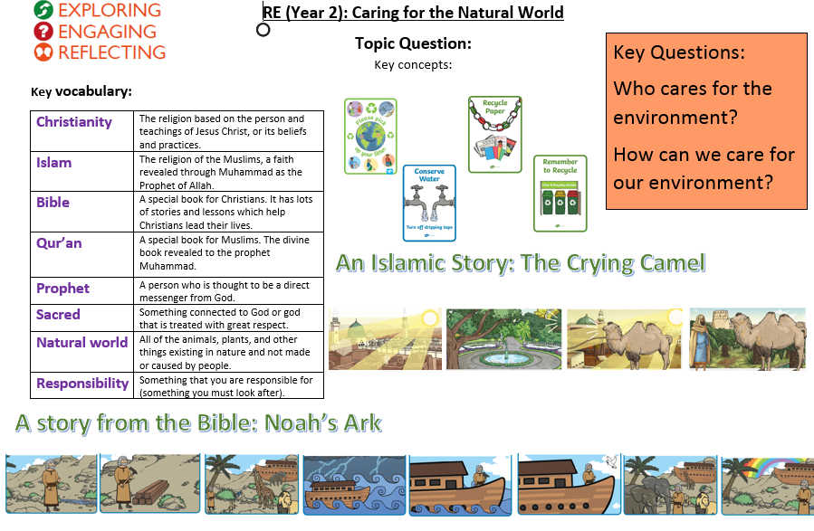

Music

Charanga

Exploring simple patterns

How does music help us to make friends?

PE

Racket and Ball:

- Racket Recap
- Hit it Back
- Top Tactic
- Cricket control
- Getting game ready
- Let’s play

Geography

- I can understand geographical similarities and difference through studying the human and physical geography of a small area of the United Kingdom, and of a small area in a contrasting non-European country.

- I can identify seasonal and daily weather patterns in the United Kingdom and the locations of hot and cold areas of the world in relation to the Equator and the North and South Poles.

- I can use basic geographic vocabulary to refer to physical features, including mountains, ocean, weather, beach, coast.

- I can use basic geographical vocabulary to refer to key human features, including city, town, village, house, office, port, harbor, shop.

- I can use atlases, maps, globes and digital mapping.

- I can use simple compass directions (north, south, east and west) and locational and directional language (for example, near and far, left and right), to describe the location of features and routes on a map.

- I can use aerial photographs and plan perspectives to recognise landmarks and basic human and physical features; devise a simple map; and use and construct basic symbols in a key.

- I can use simple fieldwork and observational skills to study the geography of our locality and the key human and physical features of its surrounding environment.

