Atlantis
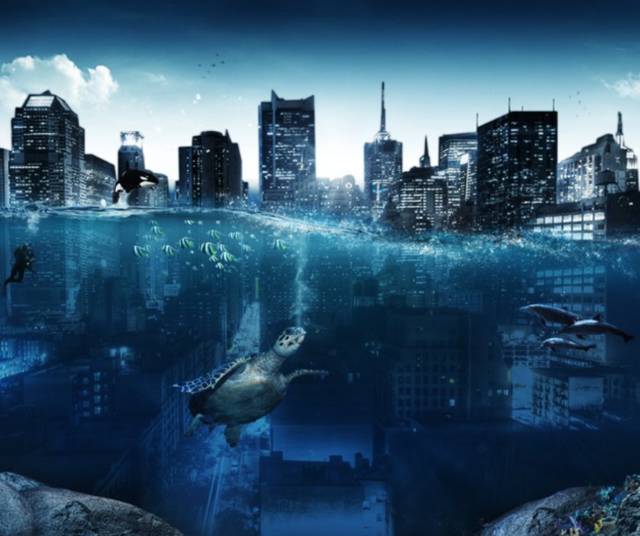
Now that you have chosen your picture, you have the choice for your genre.
- Setting Description
- Story – either writing your own or completing a story from the a story starter
- Diary Entry (from either a sea creature’s perspective or the scuba diver’s perspective)

Task 1: Question Time
- Who is the diver?
- What is he doing?
- What caused the water to rise?
- Where have all the people gone?
- Do you think there might be a real city somewhere under the ocean, waiting to be discovered?

Task 1: Vocab Collection
Use the target below to gather vocabulary that can be incorporated into your piece of writing. Think about:
- Adjectives to form expanded noun phrases
- Powerful verbs
- Figurative language (similes, personification, metaphors, alliteration, onomatopoeia)
Once you have your initial ideas, think carefully about where you place them onto the target. Place your most powerful ideas in the centre of the target, and the ideas that still require improvement (pink polished), place around the edge.
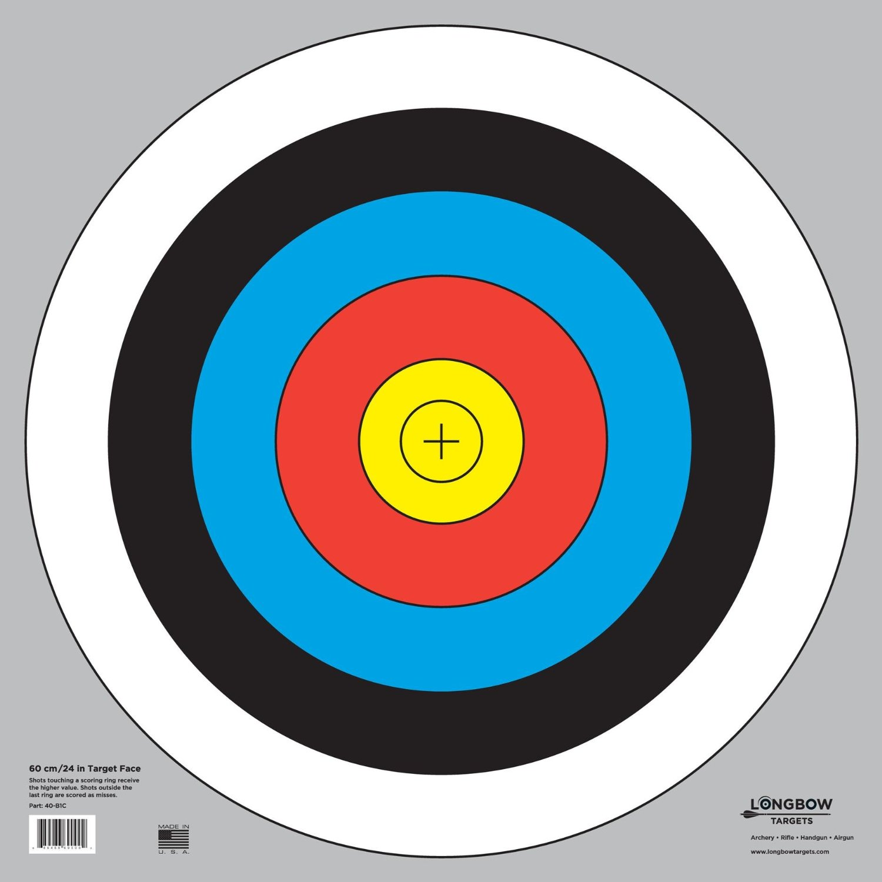
Chaotic, rare beauty
Overcrowded
Unique
Busy
Different

