The Forbidden Tower
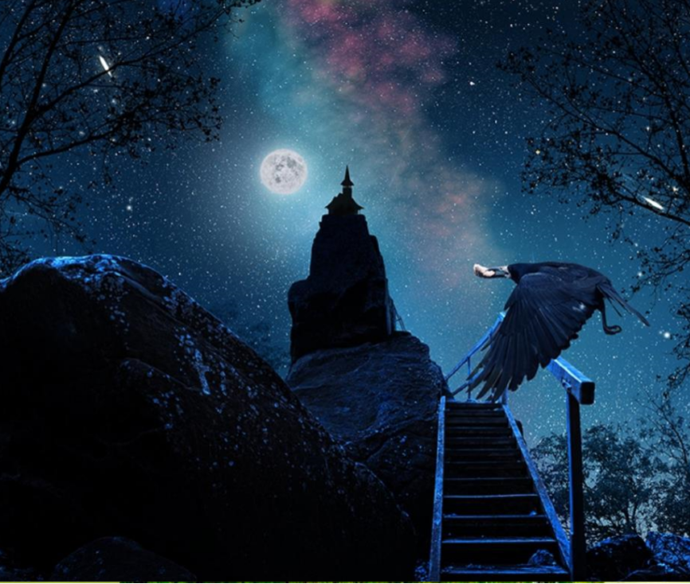

Task 2: Sentence Challenge
Can you write four sentences based on the picture that include a subordinate clause? Think about varying the position of the subordinate clause each time.
Y6 GD: Can you write two sentences using two subordinate clauses and a main clause in each one?
Now think about your compound sentences, can you use one of the following conjunctions to link your clauses together: but, or, yet, so?
e.g. This had once been a happy place, but now everything had changed.

Task 2: The Main Write
Remember that you can you can choose one of the genres below.
- Setting Description
Think carefully about:
- Incorporating the five senses
- Using figurative language for description

- Story – either writing your own or completing a story from the a story starter
Example
The night was still. Not a breath of wind could be felt. An eerie silence filled the warm evening air, broken only by the sound of the crow’s wings flapping as it returned to its nest with food.
Combined with the ghostly silhouette of the tower and the rickety pathway that led to it, the ominous silence made Lucy nervous. She felt a prickle on the back of her neck as she thought about what she might find inside the tower, and what might be lurking in the darkness around her.
Her heart began to thump inside her chest, seemingly matching the beat of the crow’s wings.
Lucy had always been slightly wary of crows; they had sooty, black wings, piercingly sharp beaks and menacing, staring eyes. The crow had settled down in one of the gnarled branches of a nearby tree. She thought it was watching her. Surely it wasn’t though? Crows didn’t do that. It must have been her imagination.
Plucking up all of her courage, she approached the stairs. They looked rotten and crumbling, as if nobody had set foot on them for years and years. The crow was still staring at her, and had tilted its head to one side as if pointing its beak towards the tower. “What was this crow up to?” she thought to herself.
“Are you trying to warn me about something?” she asked the crow. The crow did not respond, only shuffling its feet slightly on the branch, head still tilted to one side. She frowned. “Of course you’re not trying to warn me about something, you’re just a stupid bird.”
Her eyes left the crow and she ascended the first few steps on the rickety path towards the tower. “It’s just a silly bird.” Lucy muttered to herself under her breath. “Don’t be such a wimp.”
The crow watched as she left, and smiled. A wicked, cruel smile accompanied by a cackling laugh. “Silly, silly girl” it squawked. “I must tell the others she is coming.”
The crow took off into the night…
- Diary Entry (from the bird’s perspective)
Think carefully about:
- Incorporating thoughts and feelings
- Using the past tense
- 1st person

