Art Inspired by the Forbidden Tower

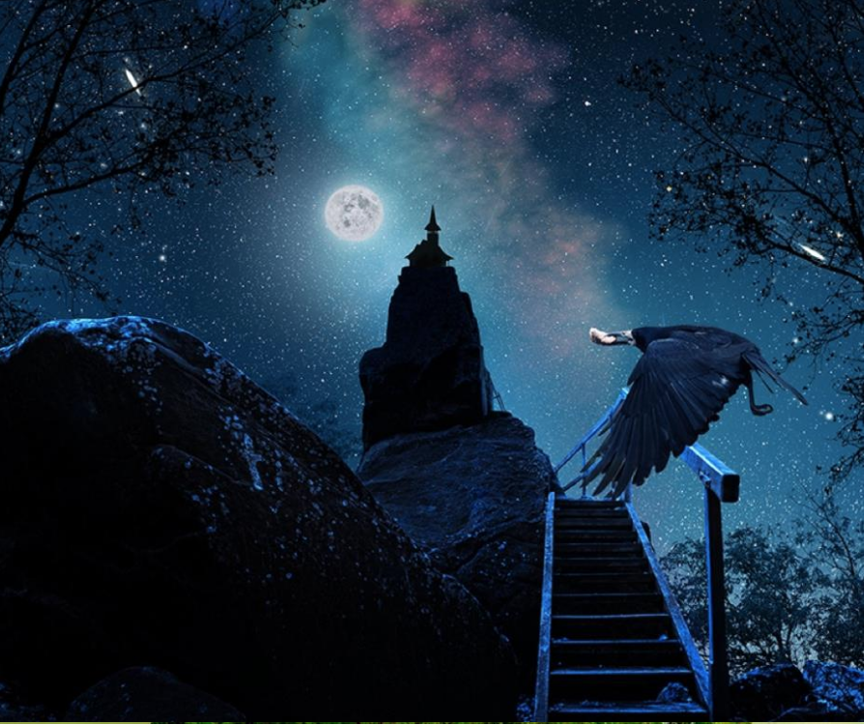

Perfect Picture!
Imagine what one of the rooms inside the tower looks like.
Draw or write down what you have imagined.
.

