Art -Week 2
Plastic in our Oceans
Your task is to create a sea creature out of recycled plastic.
This task can be completed over a number of days as you will need to collect and accumulate your recycled plastic.
Step 1
To begin with, I would like you to plan your piece of art, taking into consideration what sorts of recycled materials you are likely to have access to. Think about what you want your piece f art to be inspired by - it could link to your chosen animal from your diary entry or it could be a different animal.
Below, I have gathered and presented some ideas that you may wish to use for inspiration however if you have a new and unique idea please use that.
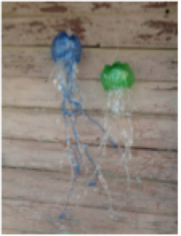
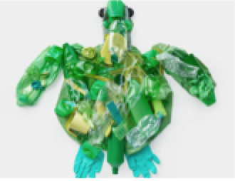
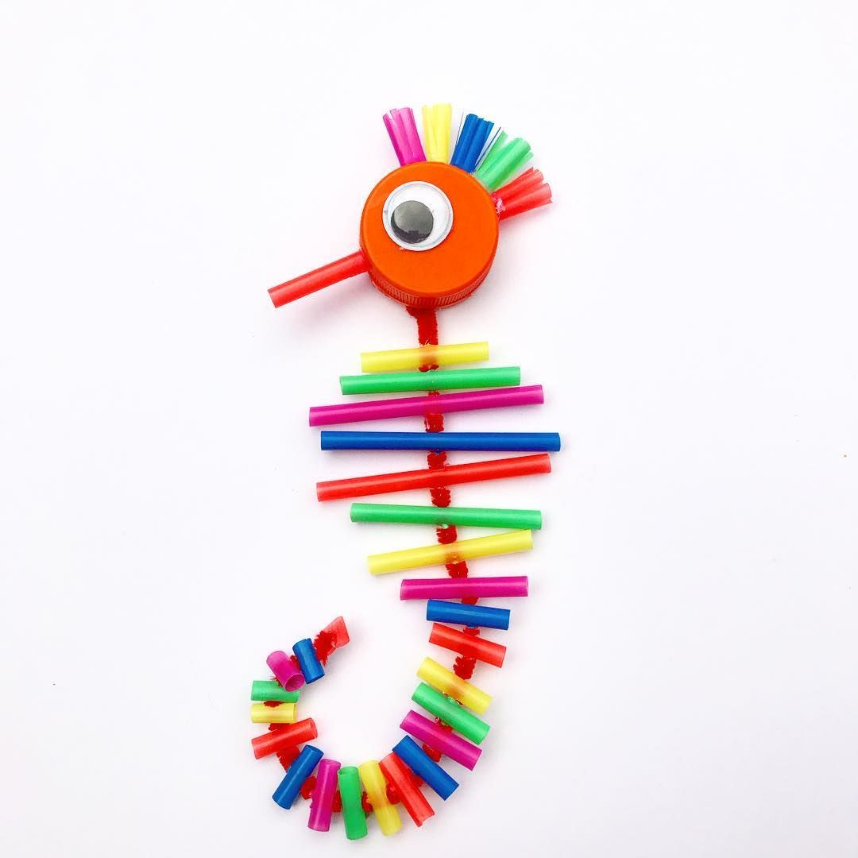
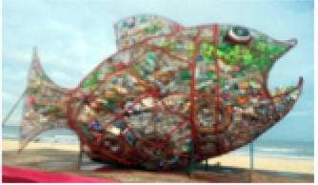

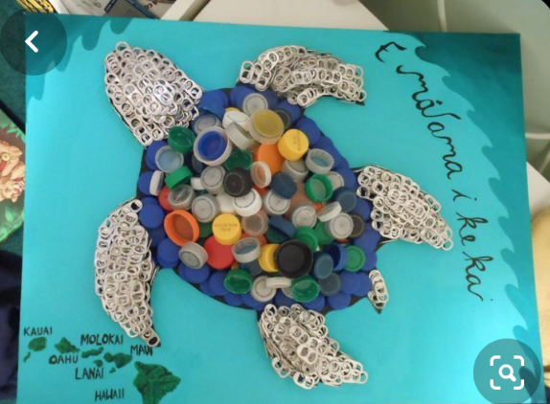
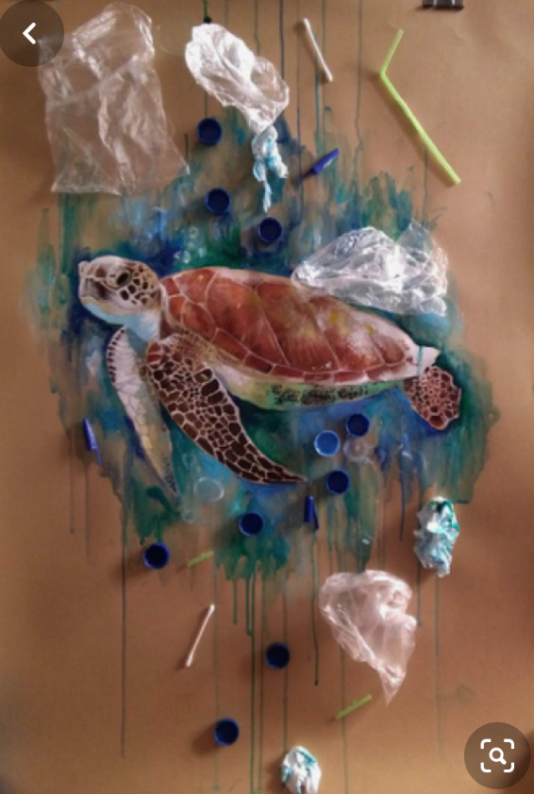

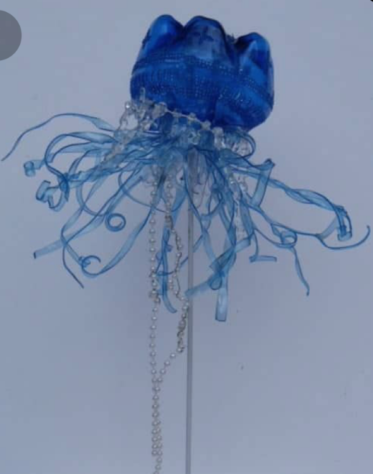

Step 2
Once you have designed your masterpiece, collect your recycled plastic. When your collection is complete, create your piece of art.

If your piece of art takes longer than this week, please don’t worry.
When it is complete, I would love to see a picture. Email me at hfletcher@cooperperry.staffs.sch

Design

