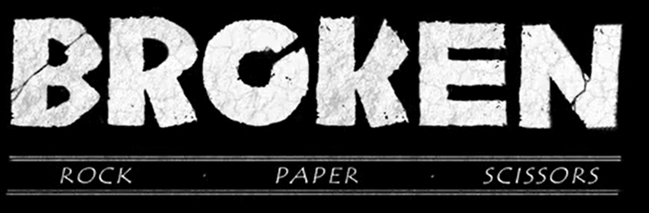

Task 3: Write the story
This week, we would like you to use the same approach that we use in school: writing a part of the story each day. From 2 minutes 29 seconds, focus on the video clip until the end.
In the next few paragraphs (approximately 2) you will include:
- The battle between Scissors, Paper and Rock
- The impact on Paper
- The impact on Rock
- Returning to the forest
- The heal of Paper
- The impact on Rock

An example of how you could start this section:
With nowhere else to go, Paper was overcome with a burst of courage. She tackled Scissors head on. Devastatingly, he disarmed her in one foul swoop. She fluttered to the ground. Rock, whose fury was unbeatable, leapt towards an injured Paper, just as Scissors intercepted. Showing no mercy, Rock launched his attack!

