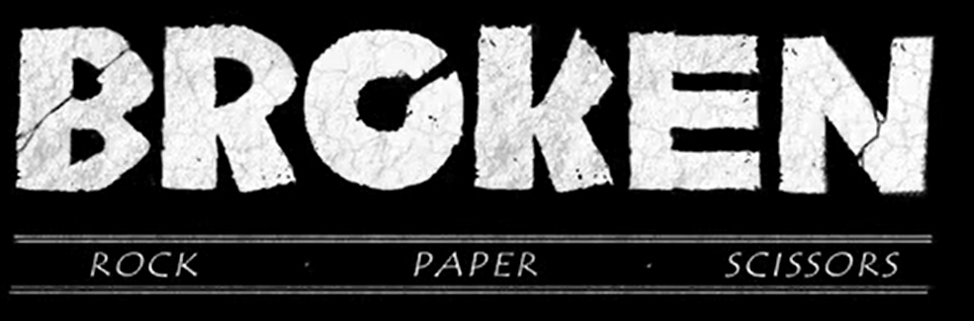

Task 3: Write the story
This week, we would like you to use the same approach that we use in school: writing a part of the story each day. From 54 seconds, focus on the video clip up to 2 minutes 28 seconds.
In the next few paragraphs (approximately 3) you will include:
- Rock spots Scissors
- Introduce Scissors
- Rock falls down towards Paper
- Rock and Paper meet
- Scissors approaches towards them
- Rock attempts to help Paper
- Rock and Paper escape
- Scissors continues to follow
- Rock and Paper meet Scissors

An example of how you could start this section:
Without warning, a sharp, ear-splitting sound pierced Rock’s sense of elation. Screech! Slash! Crash! Only a few metres away, a fierce, domineering silhouette was reaping destruction across the forest floor. Terror-stricken, Rock knew he had to act…

