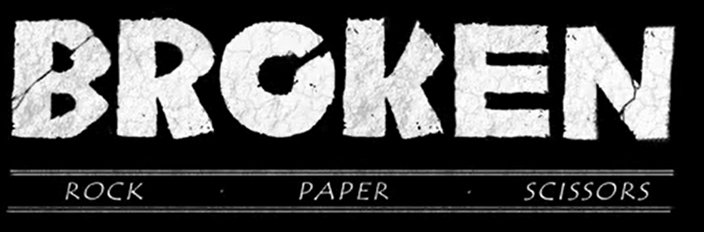
This week, your art project is inspired by the video clip ‘Broken’. We would like your art to capture the incredible scenes from the video. To do this, you will need to choose a habitat (either Paper’s or Scissors’) and explore how their habitats are represented in the video.
You may choose your art medium:
- Collage
- Paint
- Sketch
- Sculpture or 3D model
- Pastels
- Watercolour paint
Take a look at the two famous artists below. You may wish to use their artistic techniques to inspire your own piece of artwork. Giuseppe Arcimboldo uses a combination of flowers and foliage to represent a person or object. You could use this technique to represent a character or habitat (a collage of flowers could be arranged together to create a different object, for example, a tree). As you know from work that we have created in school this year, Henri Rousseau uses a folded paper technique to create a 3D layered effect. Remember to gather all of your flowers and foliage together before you arrange it into layers.

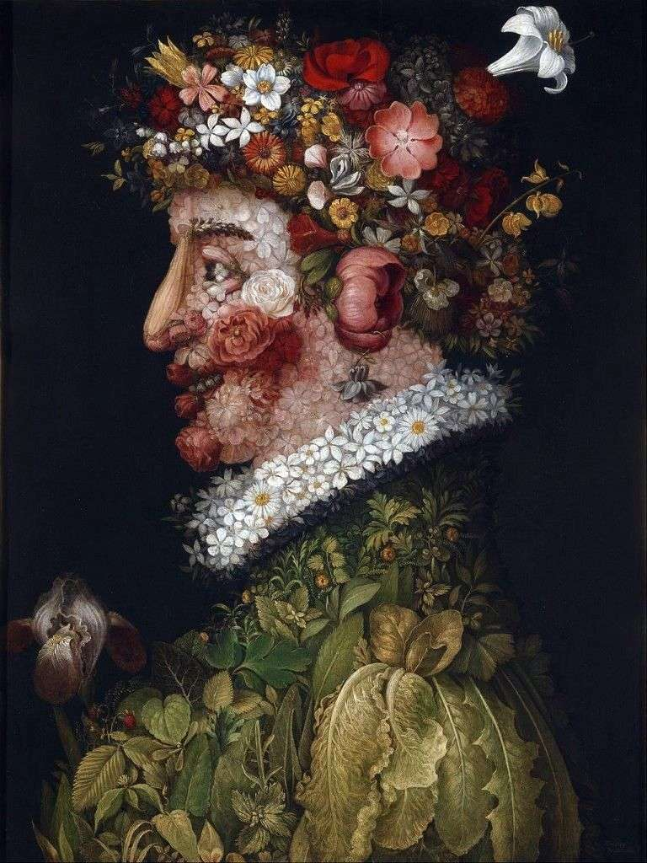
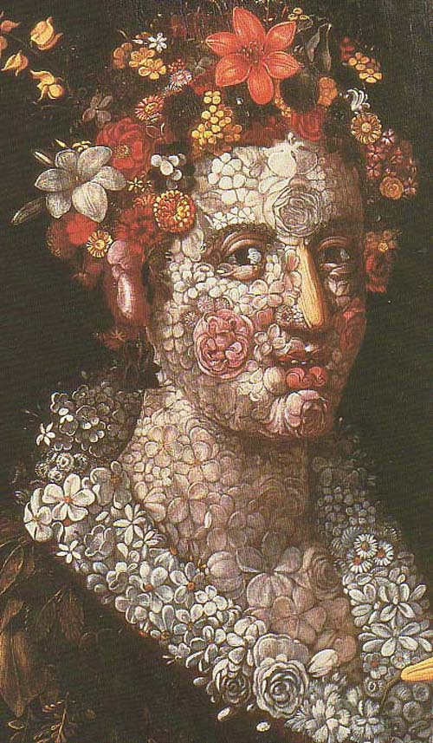
Art inspired by Giuseppe Arcimboldo
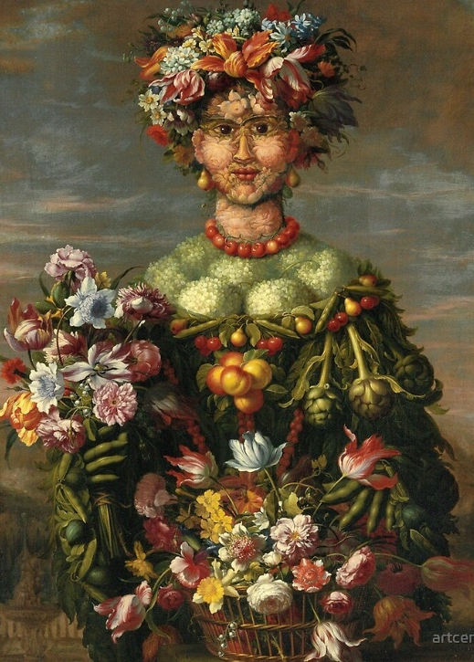

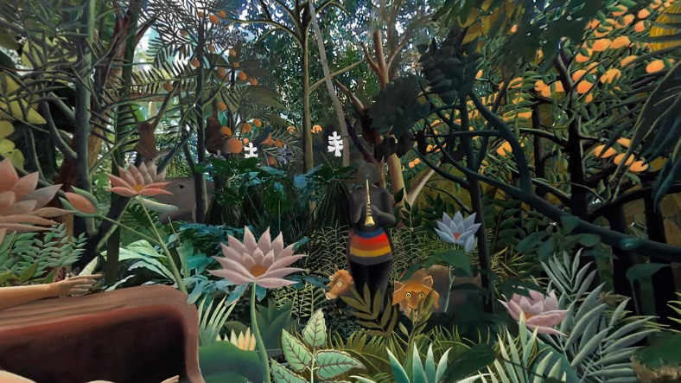
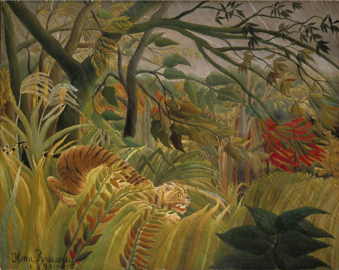
Art inspired by Henri Rousseau

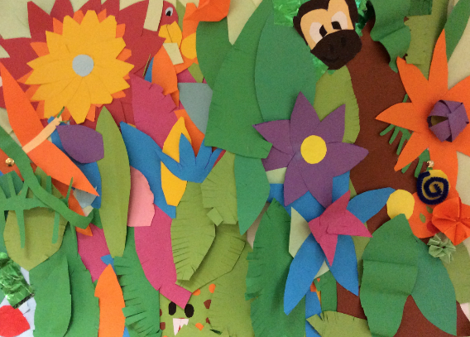
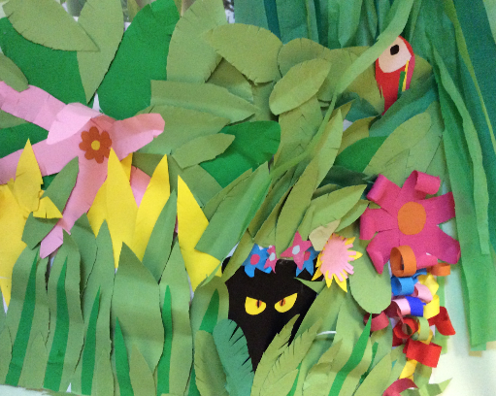
Our art inspired by Henri Rousseau
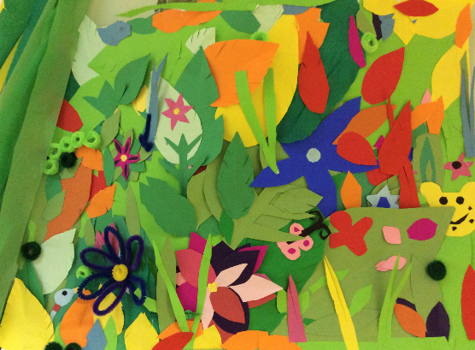

Please see the attached document (habitats) to choose a scene to create. We look forward to seeing your masterpieces.

