POSITIVE | NEGATIVE
Financial  1) For the owner, cheap labour and obedient labour. Small Children could fit in tight spaces therefore they could clean and repair machines. 2) For children/parents. They received extra wages so they would be able to buy food. | 1) For children/parents. If children were injured they wouldn’t receive any compensation.
Mental well-being/Health  People were less likely to starve in the IR because many people earned money by working and therefore were unlikely to starve. | Mental well-being  Children in the IR were sometimes abused and bullied by factory supervisors and they were punished.
Health
Sometimes dust, gas and smoke would form and many people died under 25 from lung cancer from breathing this in. Factories were cramped and hot with no windows for ventilation. This would also affect their mental well-being.
Safety
Workplaces were dangerous and at that time there was no law making employers make machinery safe and machinery was unguarded which led to injuries. Children also were responsible for repairing and cleaning the machines in factories.
Education
Children weren’t getting any education because at that time there was no school and when there was it was not there for the poor because school wasn’t free.
Step 1 Week six topic
Negatives and positives about the industrial revolution

Step 2
Speech to the Prime Minister

Dear Mr Prime Minister,
I think child labour should be abolished because children shouldn’t have to do adults work, and I think school should be free so the poor would get education and possibly get a good job. The poor should have the same rights as the rich and should be treated with the same respect. Children should not be punished for things they can or can’t do and everyone should be treated with the same respect because everybody is equal

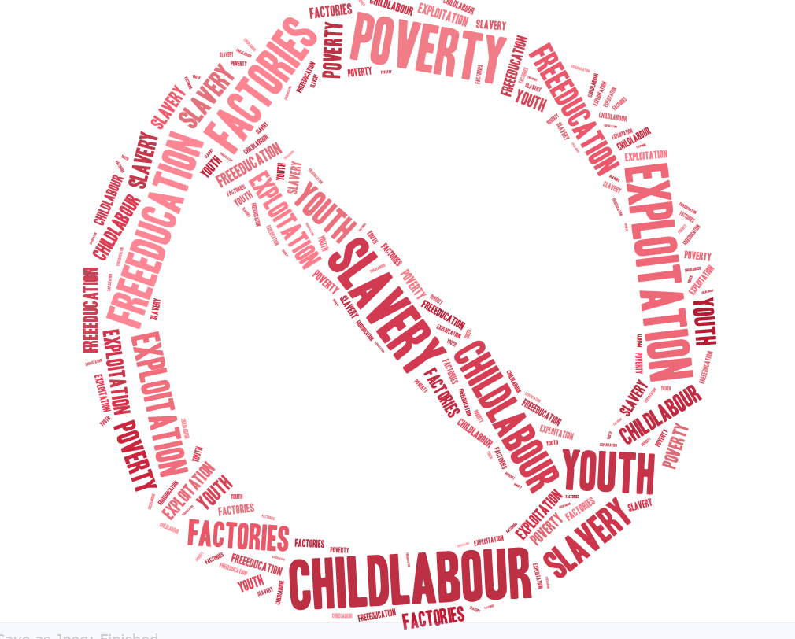

Step 3
Typical School Day in 2020
Dear Diary,
I woke up at the usual 8 o’clock sharp and as always in had a snooze for 10 minutes before being dragged out of bed I had a long day ahead of me and I had to get up I went in the shower I was very tired (like always) and decided to have a cold shower again so that my blood got pumping for the upcoming day meanwhile my clothes were warming up on the radiator, after 10 minutes of washing I headed out swiftly putting on my clothes and doing my hair we were in the car by 8:30 and we were now in the car park.

It was 9 0’clock and time for assembly then after that normally an hour of my brain doing its thing. Eventually it was break, I never had snacks at break because I was still full of my breakfast. I had to burn some calories so I was always a mad man playing some sort of running game. After 15 short minutes it was an hour of writing, which I didn’t particularly like then a relaxing time of 30 mites of reading.

It was 12:30 and that was LUNCH TIME, my favourite. I ever played football or a running game. At 1 it was time to eat I normally have hot dinners but straight after that it’s 10-20 minutes of running. Which would burn off most of the calories in my lunch. Afternoon time 2:30. It was science again not my best but not my worst topic. We would learn about cool things like the Industrial Revolution. To finish of the day we played an exciting game like heads down thumbs up until the parents arrived and then it was home time and I was waiting for a new day tomorrow. After school I would do homework or play video games with my friends.

Typical Diary Entry
December 4th, 1882
Benjamin Grove
Age: 10
Job: Coal Miner

Dear Journal,

I am 10 years old my name is Benjamin Grove I live in London in a little wooden shack with 2 brothers (Kerion and Tim) and a sister (Lucy) our mother died when I was 4 and my dad left us on my 1 birthday, ever since I’ve been protecting them.
Twas late 18th century and early 19th century when we worked in factories, and children had to work just because the people needed more help. It’s the start of the day and as always, we were drowsy, tired and devasted for the upcoming day, but we would always work our hearts of when we could for extra money. Arriving at work was hard we were always walking our legs off, so before we arrived at work, we were waiting for our upcoming 12-16hr shift. We would wake up as early as 4 AM to work in the mines, the mines were dark, and I heard poisonous gases roam the mines haunting them. I get paid 28 cense a week which pays the food off and my little sister earns 25 cense being a seamstress making our clothes.

My working day continued, and Samuel a good friend of mine slipped, his hand dropped the hammer as it landed on Michael’s toe. Punishments were coming and I had to do something I did not particularly like Michael, but as the guards came, I started laughing at the sight of Michael screaming. Me and Sam were getting punished. We got kicked out the mine and were not allowed in the mines and we did not get any money. It was 6 PM were looked at the children playing on the streets. We had no words were glared in jealousness.

When we got home, I had a sample of cheese and a piece of crusty bread it was 12 hours of hard work and I was exhausted, there was no chores today because I do not do them on Friday’s. We do our chores at the factory cleaning up the place.

It’s another long day tomorrow. I was sipping my warm milk as I fell asleep in seconds.

Sleep tight.
Love,
Benjamin

COMPARISON OF DIARY ENTRIES
In the IR they wake up at 4 am and I wake up at 8 am. The day ahead of us is different with different food and different sports. The IR are on shifts and go to school 2 hours a day, we finish at 3:30 and the IR people finish 6 or later. We have better technology with alarm clocks to wake us up and 2020 people will have more money. Children in 2020 do not have to work.
.

