Otto Malpense, star pupil at H.I.V.E. (the Higher Institute of Villainous Education) is faced with his toughest challenge yet - the Hunt. But when the students and Raven arrive something happens and it becomes clear that there is a traitor in their midst and time is rapidly disappearing to see who it is…
AFTERSHOCK

The disciples, a group of followers of the defeated artificial intelligence or AI Overlord, have sworn revenge and have made their first move - to do something to the Alpha Stream.

‘A brilliant page-turning adventure that traps you inside the amazing Otto Malpense’s head.’
Oliver Sandy, reader of over 2.8 million words



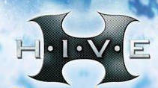

MARK WALDEN

