My review on my book
The book that I have read over the past 2 weeks is the new book by David Walliams and it is about a boy named Ned. It is a book for kids who are adventurous and like pranks.
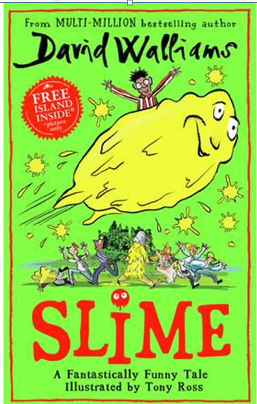
A boy called Ned had a sister called Jemima who was horrible to him.
She played pranks on him and one day he crept into her room and found a book with plans in it on how to prank Ned on his birthday. He tried to play the prank on Jemima but when he put all the goo and slime together it created a slime that could turn into anything he wants.
This meant he could go and prank all of the people who had been mean to him.
Read the story to find out more about the pranks.

